Worship Ministry
Blueprints

by Next Level Worship International, Inc.

Next Level Worship International is a non-profit ministry serving worship leaders and churches around the world.

“It is true that subtle dangers lie in organization, for if it is
overzealous if can be an unsatisfactory substitute for the working
of the Holy Spirit. But lack of method and failure to organize have
spelled doom for many promising ministries.”
– Oswald Sanders, Spiritual Leadership

This blueprint manual is a free resource, not for resale, from Next Level Worship International, Inc. The Worship Ministry Blueprint is not copyrighted. Permission to copy, use, and adapt any or all of its contents as needed is granted.
Contents

Introduction 4

Part 1: Blueprint for Designing a Lasting Ministry 5

Visions, Systems, and Processes 6

Vision Statements 7

Systems 8

Processes 9

Goals and Values for Ministries 10

Values 10

Rules 11

Goals 12

Plans 13

Part 2: Blueprints 16

Sample Processes and Checklists Index 16

Service Prep Blueprints 17-22

Rehearsal Blueprints 23-33

Team Processes 36-98

Introduction

Next Level Worship International serves worship leaders and churches around the world. We are a non-profit, charitable organization providing resources, training, and missions opportunities. Our goal is to help people experience transformative biblical worship.

Founded in 2006 by Dwayne Moore. NLW International has provided resources to church leaders in over 80 countries as of 2019. Our vision is to help Christians around the world grow deep in their love for God and others.

Worship Ministry Blueprints was written by the NLW staff and based on the previous 2016 Worship Ministry Manual by Dwayne Moore and the worship staff of Valley View Church, a church Dwayne previously ministered in as worship pastor. We are thankful for and indebted to the Valley View team who put this large volume together and allowed its use free of charge for churches around the world for many years.

As NLW International grows and has a large international influence in many nations, we want to honor the different cultures represented within our community. So rather than provide an updated version of the previous ministry manual; our goal for this new edition was to provide samples (or blueprints) for ministries to be encouraged and empowered to develop their own ministry manual.

These blueprints are just a few ways ministries can organize and communicate clearly within their specific contexts. It is our hope the advice and examples found within this material will be helpful to other churches around the world as they adapt it to work within their own ministries.

Worship Ministry Blueprints is not copyrighted. Permission to copy, use, and adapt any or all of its contents as needed is granted.

Please consider financially supporting our ministry so we may continue to provide quality training for those with limited resources but a desire to learn. Please visit our website at nextlevelworship.com/donate for ways in which to fund our non-profit organization.

Next Level Worship International, Inc.
PO Box 252, Lacey’s Spring, AL 35754 USA
+1-877-699-3226
office@nextlevelworship.com

Part 1

Visions, Systems, and Processes

Where there is no vision, the people are unrestrained,
But happy is he who keeps the law. – Proverbs 29:18

A vision, or main thrust, is imperative for every organization. Without an idea of what the organization is trying to accomplish, there is no goal or guidance among the people working for the organization. The vision forms what strategies, or systems, are put into place to ensure the organization is achieving its aim. The systems fuel the processes which need to be in place and communicated to all involved in producing the end product.

This section will cover writing a vision statement, successful systems which are formed by the vision, and the processes you will want to put in place to organize your ministry and ensure its success.

Vision Statements

When writing a vision statement for your church ministry, you will want to keep several things in mind. First, at NLW we believe the worship pastor is under the authority and headship of the senior pastor. Therefore, the worship ministry’s vision statement should be cultivated and approved by your pastor. Second, the vision statement should be short and memorable so anyone involved in the worship ministry can state it easily. Thirdly, the vision statement should support your church’s vision. For example, if your church’s vision is to make disciples, the music ministry’s vision should, ultimately, be to make disciples along with a brief, tailored statement on how the music ministry will seek to accomplish the church’s vision.

Lastly, the vision statement must be specific to your ministry and giftings. The body of Christ is made up of many parts (1 Corinthians 12:12-27) our vision will be God-given, according to the giftings He has given each one and called them. Everything your ministry does will be filtered through your vision and almost always, when a ministry is stretched beyond its giftings and resources, the entire ministry suffers. Seek God’s guidance as you write your vision statement and recognize we, as humans, are finite beings with finite resources. God provides as He calls, but we must also have the humility to understand our limitations and invite other ministries into partnership with us.

For more resources on vision statements and how to move your vision forward visit, https://www.nextlevelworship.com/visionbook/.

Examples

NLW International
“To help Christians around the world grow deep in their love for God and others through transformative biblical worship.”

Valley View Church, Worship Ministry
“Our vision for the worship and creative arts ministry is to be a ministry which builds quality worship services, quality worshipers, and quality worship leaders.”

Grace Church, Worship Ministry
We at Grace Church believe that God calls the church to gather together and worship corporately to celebrate the work of the gospel. We come together to remember God’s great story and our humble participation in it.

If your ministry does not have a vision statement, begin by drafting one below:

___________________________________________________________________________________

___________________________________________________________________________________

___________________________________________________________________________________
Systems

Your ministry’s systems, or strategies, will define how to go about accomplishing your vision. The overall strategies may rarely change, and they should be generic enough to be implemented in any situation within your ministry. Your ministry strategies may use language specific to your vision and theme.

Examples

Sample Church
For producing quality worship services:
Planning>>Communicating>>Rehearsing>>Producing>>Evaluating

For producing quality worshipers:
Watch worship>>Give worship >>Live worship>>Share worship

For producing quality worship leaders:
Worshiper>>Apprentice>>Leader>>Overseer

Grace Church
Corporate worship is the overflow - out of and into - individual worship during the week. We come together to remember God’s great story and our humble participation in it. We do this in a variety of ways including:
preaching
teaching
singing
prayer
stories of life change
baptism
communion

Questions to help you build your systems:

- If your church has a strong discipleship drive, do you have a system to develop leaders within the music ministry?
- Do you need a system to on board new team members?
- If your church has a strong desire to reach the lost, what systems need to be put into place so the music ministry can come alongside other ministries in this effort?

Processes

Once the vision and overall systems to accomplishing the vision are solidified, you can begin getting into specifics by writing processes, or checklists, which your team will follow to fulfill the vision. While systems rarely change and are themed, or analogies, in order to make the vision memorable; processes and checklists change frequently and are updated accordingly anytime a process is ineffective or a new system is put into place, i.e. new soundboard, new lighting system, new computer software, etc.

Processes should be simple to follow and written with the desired outcome in mind. The steps and details provided in each process will help produce consistent results regardless of changes in go into compiling processes for each item within your ministry.

The following is a list of processes you will want to consider for music ministry:

o Worship/Service Planning Processes
o Communication Processes
o Rehearsal Processes
o Band Processes
o Choir/Vocal Processes
o Production and A/V Team Processes

Questions to help you develop and evaluate your processes:

- Who will be reading this process?
- If someone did not know how to run ________, could they run this system by following this process step by step?
- Does this process make working through our systems easier?
- Are these processes in line with our vision?
Goals and Values for Ministries

Values

Similar to a vision statement, compiling a list of values is important so the people involved in your ministry understand how they will be guided along the processes and the rules in place for each individual. Values also help determine the boundaries within the ministry, goals, and ideals. Additionally, values can help solidify the vision among your team.

A few of Sample Church’s Values:
We value authentic and engaging praise on the platform (Psalm 40:3)
Therefore we…
Make time to grow together as worshipers
Strive to internalize our music
Try to dress in a way not to distract from worship
Evaluate how well we engage and lead
Strive to anticipate possible changes as the Holy Spirit leads and prepare when possible

We value musical excellence and creativity (Psalm 33:3)
Therefore we…
Plan and rehearse weeks in advance
Play with a click track on most songs
Use a loop on some songs
Create our own arrangements of some songs
Feature songs we write from time to time
Rehearse the band and choir weekly and worship leaders before they sing
Rehearse entire service on Sunday AMs w/all service personalities & tech

We value diversity of music and leaders on the platform (Romans 12:10)
Therefore we...
Mix up choir leading, ensembles leading, and individuals leading
Play/sing various styles of music
Have a creative and unusual service each month

We value pouring into people in our ministry.
Therefore we…
Mentor all we feel led to
Offer training opportunities for all leadership levels within our funnel.

Now, write your church’s values below:
____________________________________________________________________________________

____________________________________________________________________________________

Rules

Along with stating the values you aim to uphold in your ministry, you may find it beneficial to implement rules and regulations which support the values and/or the vision. Below, Sample Church’s rules clearly support the ministry’s vision statement.

OUR RULES

1. We will produce excellent, creative and effective services.
We will follow our checklists and processes across the board.
We will insist on consistency from everyone.
We will ask, seek and knock—looking to God for our every need.

2. We will produce effective worship leaders.
We will insist on all leaders doing Pure Praise and attending rehearsals and services.
We will constantly mentor and empower others.
We will follow our funnel process with everyone.

3. We will help produce true worshipers within our congregation.
We will work with our pastor and leadership team to think of better ways to teach our people.
We will never be content with Sunday worship only.
We will never quit praying for our people and loving them.

Goals

Every year, it is important to reevaluate your ministry’s effectiveness in accomplishing its vision. Creating a list of measurable goals is helpful in this evaluation. It is also beneficial to list goals in order to continue momentum. It is easy to become accustomed to ministry standards and become stagnant. Below is Sample Church’s Goals for the New Year along with the objective and purpose of their ministry goals.

NEW YEAR WORSHIP ARTS MINISTRY GOALS

OVERALL OBJECTIVE
We’ve named this our “Year of Growth.” In other words, we believe God will honor our efforts to follow our model of ministry as we continue to consistently build quality worship services, worshipers, and worship leaders.

SPECIFIC MEASURABLE GOALS
Train all ministry leaders and overseers to consistently follow our systems
Build service bands into two rotating teams
Build worship choir to 50 consistently strong
Move every person involved in music ministry through our mentoring process
Have multiple training events for band and vocals and production
Team-write original songs
Train our vocalists through coaching, lessons & video self-evaluation
Get more of our team to participate in “worship evangelism” outside our walls
All volunteer overseers mentor at least one person this year
Rehearse weekly with the main band
Attract more and better musicians
Strengthen the middle and high school bands
Improve Livestream audio quality with separate mix person/board
Train and put in place Sunday tech managers
Train and put in place Training Director to track progress of apprentices
Build a Video Team
Establish consistent Sunday AM real-time rehearsal with band & tech
Hire consistent drummer & keyboardist

Write out goals you would like to accomplish in the coming year:

____________________________________________________________________________________

____________________________________________________________________________________

____________________________________________________________________________________

Plans

Every good goal is achieved by breaking it up into smaller steps, or plans. Plans serve to accomplish goals; goals are needed to attain growth (spiritual and numerical) and designed to support the processes for each system. The following plan is taken from Sample Church’s strategy to implement its system for producing quality worship leaders by taking individuals from Worshiper to Apprentice to Leader, and finally, to Overseer.

NEW YEAR PLAN

FOR BUILDING WORSHIPERS:
Instruct congregation about worship principles through creative teaching/songs
Nights of Worship (tentatively in April, September and December)
“Gospel” Night of Worship in September
Adult choir weekly teaching devotionals
Worship Matters bible study in Spring and Pure Praise in Fall (open to anyone)
Worship Choir Retreat in January
Music-reading workshop in March (open to anyone)
Monthly Gatherings for involving more creatives
Christmas play and service projects for whole church

FOR BUILDING APPRENTICES
Formalize the Apprentice Program and train a coordinator to help lead it
Worship staff mentoring of key leaders in band, choir, & production
Opportunities to lead a song or share a devotional during rehearsals or services
Opportunities to work in production booth or help staff in other ways
Song-writing retreat (Spring)
Production workshops in-house for sound, cameras, production
Worship Leader Conversations (Wednesday nights once a month)
Worship Matters bible study with tech team
Team Nights (or Leadership Nights) for training 3 times throughout year

FOR BUILDING LEADERS
Opportunities to lead worship and be evaluated in: meetings/retreats, Wednesday night main service, Sunday services, other worship nights
Band/VT Retreat (March)
Continued mentoring by worship staff
Worship Leader rehearsals on week before they’re scheduled to sing
Worship Leader Intensive (early October)
Pure Praise study with Sunday main bands and vocal teams
Mission Band playing in local festivals and venues
Band & VT conference (local)

FOR BUILDING OVERSEERS
Continued bi-weekly mentoring by worship staff & overseers
Worship planning/evaluation and assisting of worship staff
Conference attendance for key leaders (September)
Worship staff one/two-day retreats (early January and mid-September)
Leaders and Overseers Retreat (early May)

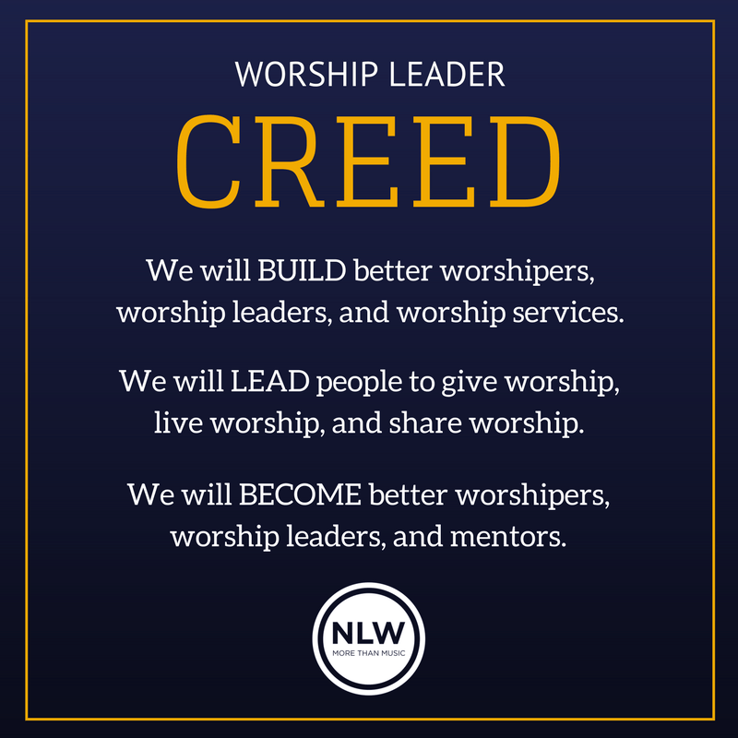

Part 2: Blueprints

This section is comprised of blueprints, or sample processes and checklists, gathered from members of our NLW Community. These are real-life examples churches use in their ministries. You have full permission to take these and use them as blueprints in your ministry. It is not an exhaustive list and may be more beneficial to use portions and/or combinations of these to fit your specific context. We are especially grateful to our NLW community for their contributions.

Processes included in this section are:

Service Prep Blueprints
- Service/Worship Planning Samples
- Service Checklist Samples
- Service Schedule (or Run Sheet) Samples
- Song Selection Process Samples
- Post Service Critique Forms

Rehearsal Schedule Blueprints
- Daily/Weekly Tasks Checklist

Day of Service Blueprints
- Sample Service Run sheet

Team Processes
- Leadership Communication Processes
- Potential Team Member Assessment Processes
- Example Checklist for Auditioning a New Musician/Worship Leader
- Example Checklist for Auditioning a New Choir Member

Worship Planning Outline

Date: _______________ Sermon Series: ____________________________________________

Main Idea & Scripture: ________________________________________________________________

Songs:

1.

2.

3.

4.

5.

Scripture Ideas:

1.

2.

3.

Other special elements to consider:

Announcements

1.

2.

3.
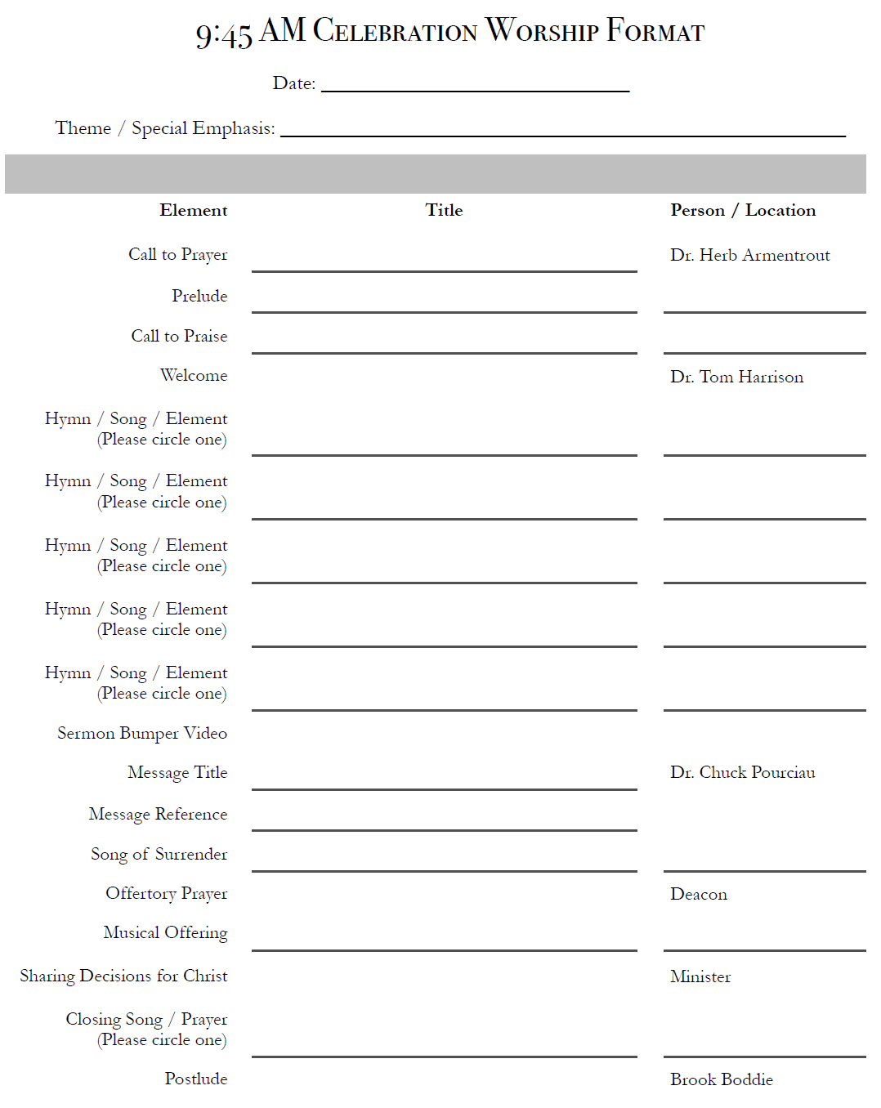
SONG SELECTION PROCESS

Every 3-4 months we ask for song ideas and suggestions from our worship staff and some volunteer leaders. We also invite input from a few key church members, to help us get a broader perspective on what our people might enjoy. In addition, we are always on the lookout for new songs and new arrangements, as well as older songs to bring back. We search the Internet for ideas, and we ask other worship leaders and pastors what their churches are singing. This constant feedback and scrutiny helps maintain biblical accuracy, stylistic diversity, and cultural relevance in our songs and creative elements. Our worship arts pastor and lead pastor make the final decision on what we sing.

There are three fundamental criteria for any song we select:
- Do the lyrics accurately represent who God is?
- Do the lyrics accurately communicate what God has revealed through His Word?
- Will the song represent the worshiping hearts of our congregation?

Additionally, we consider:

The style and tempo of a song. Would the majority of the congregation appreciate this particular style? Or, conversely, would the song help “stretch” our people out of their comfort zones?

The difficultly level and “playable-ness” of a song. Can our band and singers deliver this song with excellence? Do we have enough time to practice and prepare the song well?

Our overall need for the song. Is the song a good fit for us at this time? Does the song complement the other songs in our seasonal set? Do we already have songs planned that are similar in style and tempo? Do the song lyrics support upcoming sermon themes and service emphasis?

Communication Timeline for Services

6-8 Weeks Out
Plan service order with worship staff in staff meeting
Plan creative elements with worship staff in creative meeting
Choose singers/leaders with worship staff in staff meeting

4-5 Weeks Out
Confirm keys w/song leaders
Post and provide songs/demos/music for leaders and musicians
Alert team members about rehearsals
Confirm video/creative elements

2-3 Weeks Out
Assign and confirm A/V Team
Assign and confirm song leaders
Assign and confirm musicians
Assign and confirm rehearsal leaders
Confirm service order and provide to all involved
Confirm song keys/arrangements with singers and musicians

1 Week Out
Plot stage arrangement
Post and communicate band rehearsal run sheet
Post and communicate choir rehearsal run sheet
Send sermon title/notes to Tech Team
Post and communicate service run sheet
Print run sheet for service and have extra copies available

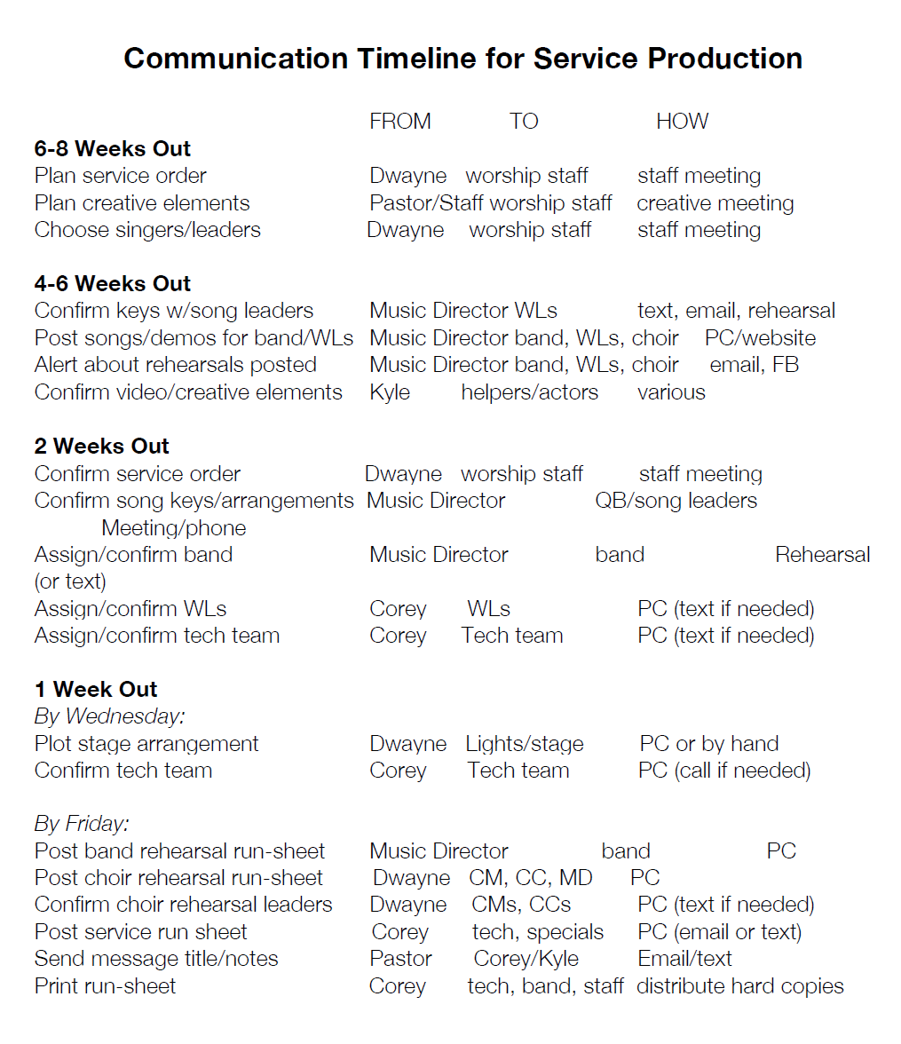

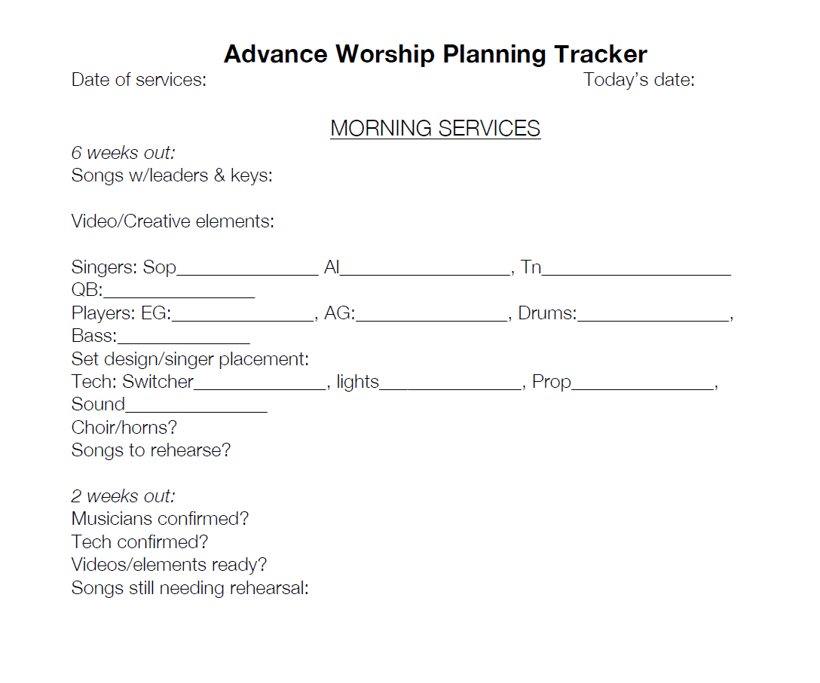
Worship Pastor’s Rehearsal Checklist

Before Rehearsal:
- Create list of songs needing to be rehearsed and prioritize according to familiarity
- Communicate songs and creative elements to all teams before rehearsals
- Equip/provide vocalists and musicians with keys/music before rehearsals
- Determine flow and order of songs; make changes as needed
- Create run sheet for rehearsal
- Have the musicians confirmed attendance for rehearsal and service?
- Have the worship leaders confirmed attendance for rehearsal and service?
- Have the A/V team members confirmed attendance for rehearsal and service?
- Are the videos/slides ready for rehearsal?
- Are the creative elements ready for rehearsal?
- Clean up stage from last service
- Set stage for this service
- Have water ready for team
- Sound check
- Greet the team as they arrive

During Rehearsal:
- Pray and start on time
- Rehearse transitions between songs
- Rehearse stage presence and musicality with musicians and singers
- Is the soundperson comfortable with sound and volume during rehearsal?
- Are the musicians and singers adequately prepared for upcoming service?
- Are the lyrics correct on the slides/videos?
- Do musicians when they come in and is everyone playing and singing together / in tune?
- Have fun and encourage the team
- Encourage excellence, musicality, and memorization
- Encourage WORSHIP OF GOD!
- Make important announcements for upcoming service
- If time permits, rehearse entire service from start to finish omitting speakers/sermon
- Pray and end on time
- Clean up stage after rehearsal and ensure readiness for service

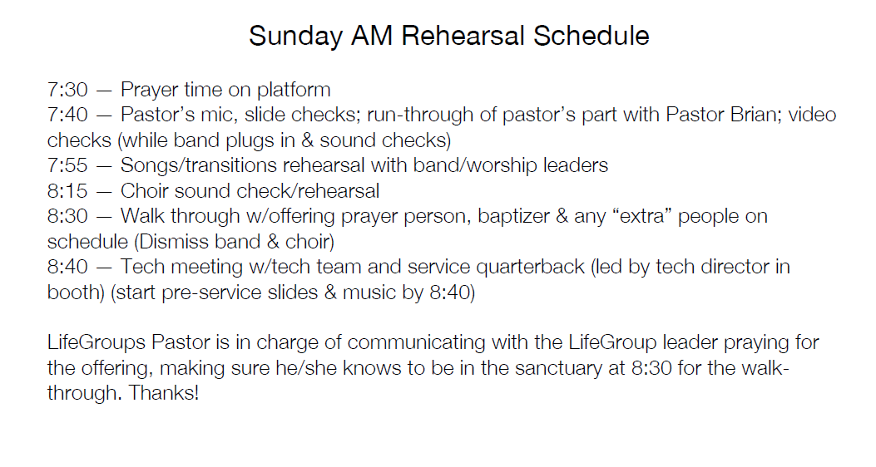
CHOIR REHEARSAL RUN SHEET

Sun, July 13th 5:45 PM - 7:30 PM in Choir Room

5:35 Pre-rehearsal song demos playing

5:45 Prayer & one-minute testimony from choir member

5:50 Announcements given by choir leader

5:55 Rehearse the following songs
5:55 Holy Wedding Day (Hallelujah bridge)
6:05 Of the Father’s Love Begotten
6:20 All Hail the Power/Holy, Holy, Holy/Revelation Song
6:35 Pass Me Not
6:55 To God Be the Glory

7:10 Devotional/prayer time – Music Director

7:20 Closing – choir member

BAND REHEARSAL RUN SHEET

Sun, July 13th 4:00 PM - 5:30 PM in Sanctuary

3:45 Pre-rehearsal song demos playing

4:00 Prayer & one-minute testimony by band member

4:05 Announcements – Music Director

4:10 Rehearse the following songs
 4:10 Holy Wedding Day (Hallelujah bridge)
 4:20 Of the Father’s Love Begotten
 4:35 All Hail the Power/Holy, Holy, Holy/Revelation Song
 4:45 Pass Me Not
 4:55 To God Be the Glory

5:10 Devotional/prayer time – Music Director

5:20 Closing – band member

A/V and TECH REHEARSAL RUN SHEET

Sun, July 13th 4:00 PM - 5:30 PM in Sanctuary

3:45 Pre-rehearsal song demos playing over main speakers

4:00 Prayer & one-minute testimony with the band

4:05 Announcements – Music Director

4:10 Band will rehearse the following songs
 4:10 Holy Wedding Day (Hallelujah bridge)
 4:20 Of the Father’s Love Begotten
 4:35 All Hail the Power/Holy, Holy, Holy/Revelation Song
 4:45 Pass Me Not
 4:55 To God Be the Glory

5:10 Devotional/prayer time with the band – Music Director

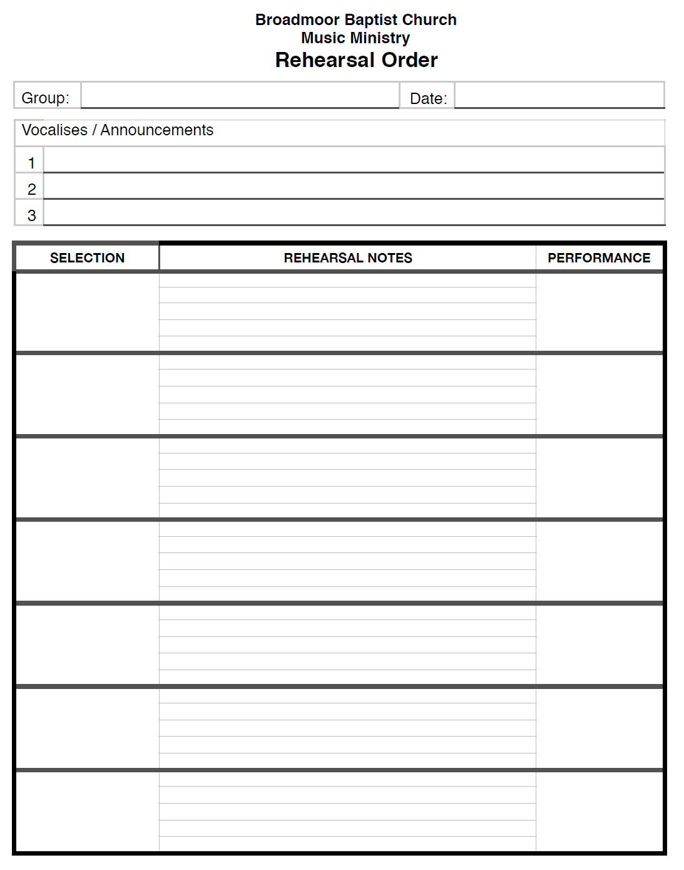
DAY OF SERVICE REHEARSAL RUN SHEET

7:30 Prayer time on platform

7:40 Pastor’s mic check and sermon slide check and video checks

7:45 Musicians/worship leaders arrive, set-up, plug-in, tune & sound checks

7:55 Rehearse song transitions with musicians and worship leaders

8:15 Choir arrives and sound check and rehearse songs with all music team on platform

8:30 Run through service transitions with all involved (ushers, announcements, baptisms, offering prayer person & any other people involved in service)

8:40 Dismiss all & start pre-service music/slides/video

8:45 Tech/Production team meeting w/tech team in sound booth

8:55 Everyone in place and looking professional

8:55 Tech team starts 5-minute count-down timer

9:00 Service starts
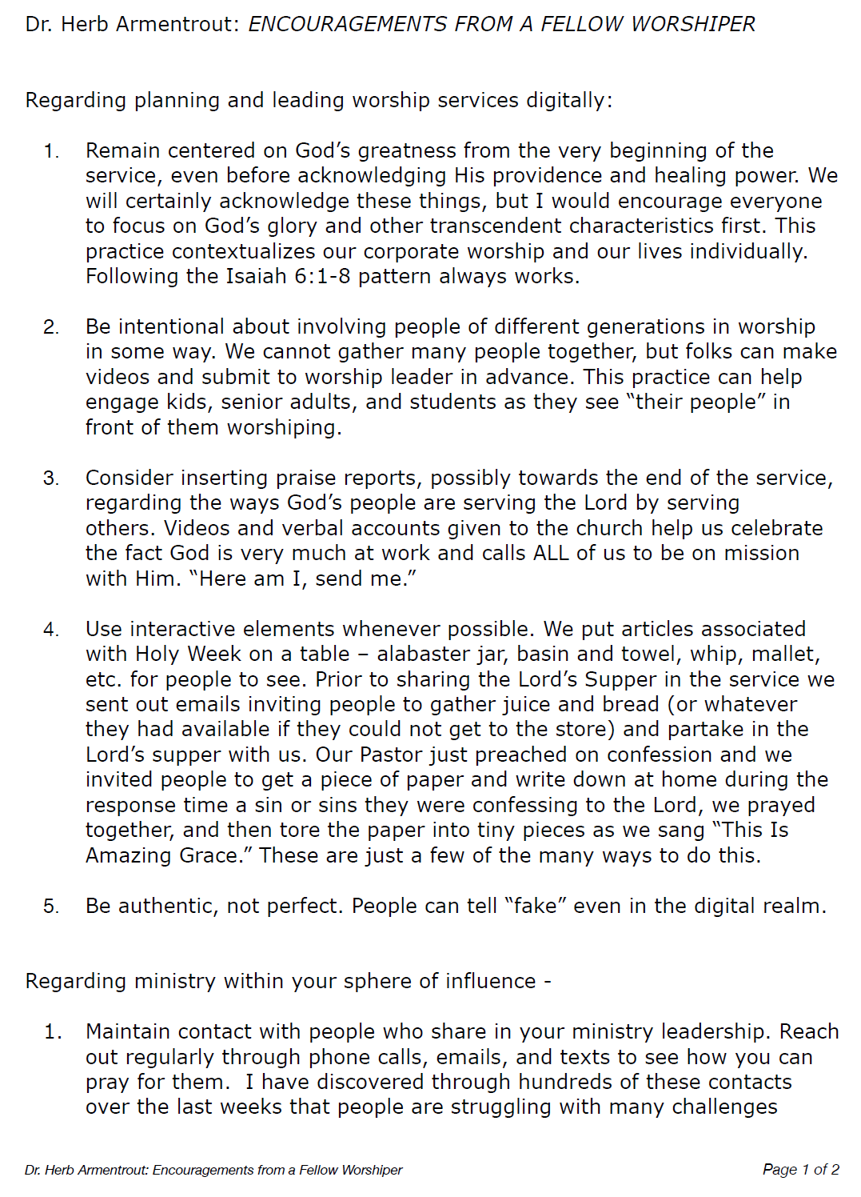
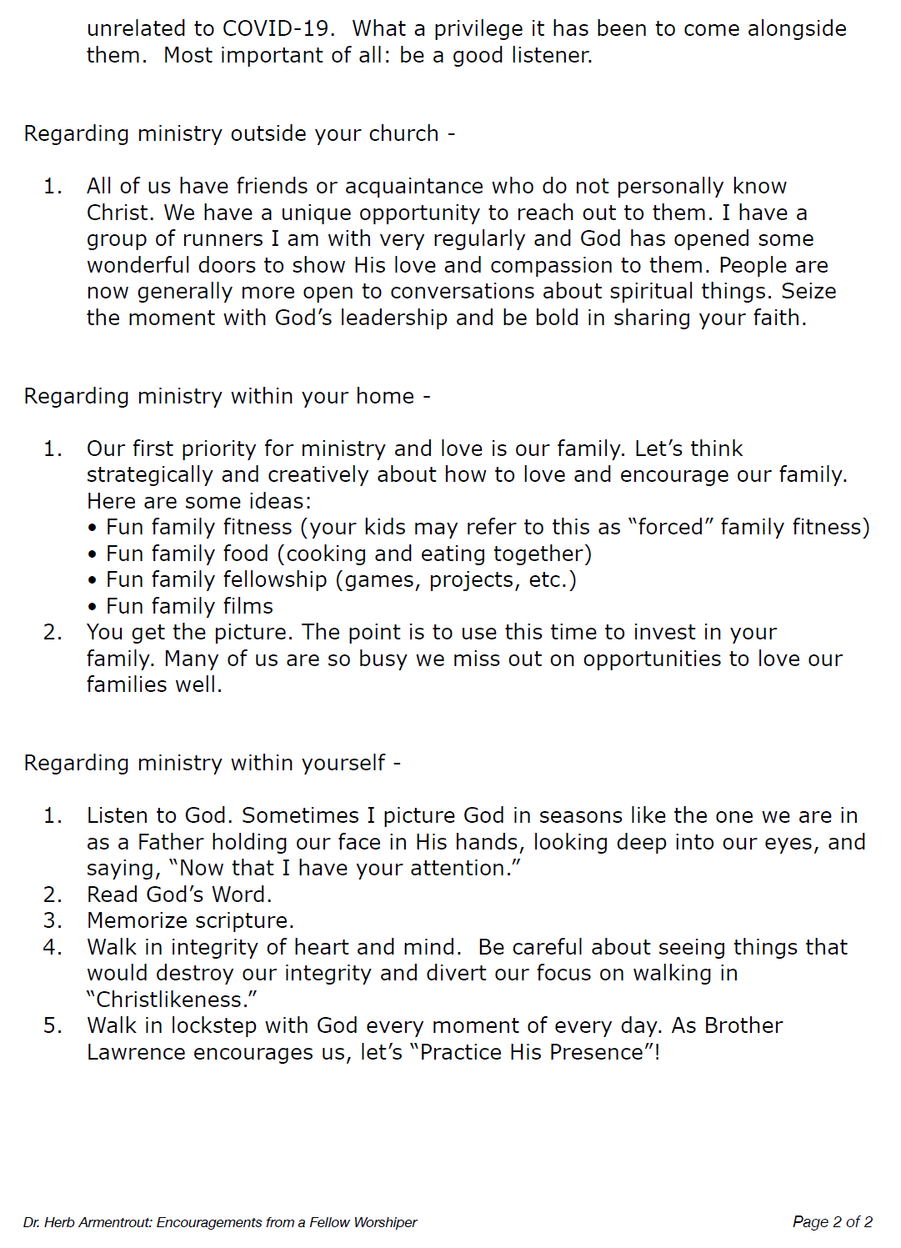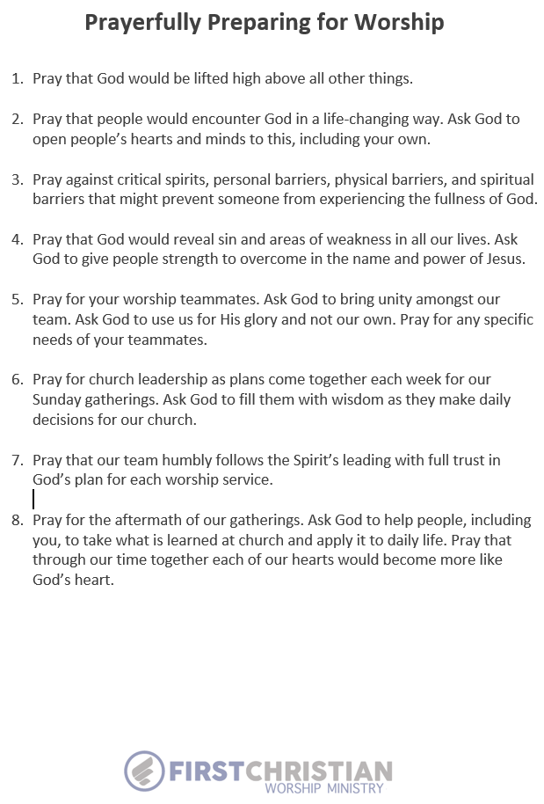

Service Run Sheet

9:30am Sound check/Band rehearsal

10:20am Pre-service music

10:30am

Opening Song: Ancient of Days
Key: C
Worship Leader: Dawn

Welcome & Announcements given by Deacon of the Week

Fellowship

Pastoral Prayer

Worship Together: Jesus Lead On
Key: D
Worship Leader: Dawn

Jesus, Lover of My Soul
Key: Eb-F
Worship Leader: Janae

Offering: Great I Am
Key: Bb
Choir Special

Sermon Bumper Video: I AM… THE GOOD SHEPHERD

Message Sermon slides will be used

Commitment Response: Overcome
Key: G
Worship Leader: Bill

Savior Like A Shepherd Lead Us
Key: Am
Worship Leader: Dawn

New Hope AM Service August 20th
Bold script = notes for accompanists

Prelude

Welcome and Announcements

Fellowship of God’s People

Congregational Worship
Forever (His Love Endures Forever)
Fairest Lord Jesus
Worthy, You Are Worthy
Worthy of Worship

Reading of Scripture

Offertory Prayer

Offertory Special
Grace Alone
New Hope Sanctuary Choir

Special Music to Prepare Our Hearts for God’s Word
Mrs. Donna Vollrath

Proclamation of God’s Word by Pastor Jeremy

Our Response to God’s Word
The Potter’s Hand

Closing Chorus
The Family of God

Mrs. Kay

given by Pastor Jeremy

Forever (His Love Endures Forever)

(G) p. 45 in More Songs for P & W 2
(Eb) p. 87 in Hymnal
(Eb) p. 106 in Hymnal
(F) p. 153 in Hymnal

Congregation reads Scripture aloud

Deacon of Week

CD split-track #54-58

CD track #2

(G) p. 103 More Songs for P & W 2

(F) p. 203 in Hymnal

Team Processes

Let the word of Christ richly dwell within you, with all wisdom teaching and admonishing one another with psalms and hymns and spiritual songs, singing with thankfulness in your hearts to God. Whatever you do in word or deed, do all in the name of the Lord Jesus, giving thanks through Him to God the Father. – Colossians 3:16-17

Having a vision and executing services every week is important as well as clearly communicating your ministry’s standards and expectations of roles at the beginning of any relationship. This section provides responsibilities, processes, and checklists for those in many roles within music ministry.
OUR TEAM MEMBERS

TEAM VALUE

The leaders and overseers in our worship arts ministry are our team members.
These are vital servants who help lovingly and carefully develop our
products. They work diligently within their assigned areas of our systems to keep
everything going from week to week. Our team is the life force of our worship arts ministry!

TEAM EXPECTATIONS

Support is important. We try to stay in close touch with our staff and volunteers,
making sure they have the tools and the training they need to do their jobs well
and serve most effectively in and through our worship arts ministry.

Team Members are not machines. We value our team as people who have lives
outside our church. They have families. They have joys, hope and dreams. And
they have problems and issues. We recognize that as they minister within our
worship arts ministry, we should look for ways to also help minister to them.

The bar is high. We are all imperfect and in need of new mercies every day.
Nonetheless, worship arts ministry volunteers are held to a high standard. We
require you not participate in activities that would give reason for people to
question your leadership or position as part of one of our most visible volunteer
teams. Understandably the bar is set high, as we have the privilege of helping lead
others into the manifest presence of God, but it is also a position of leadership
that we take very seriously. Therefore, if at any time we have reason to question
your personal standards and practices, we will not hesitate to address the matter
with you, taking biblical steps as needed.

Inspection is vital. An old adage says, “People model what you expect or
inspect.” We are constantly inspecting our own work and the work of our ministry
leaders. We do this not to look for fault and find outlets to cast blame on others.
Rather, we want to improve what and how we minister. We recognize that this life
is short, and the ministry God has called us into is urgent and important. Thus, we
must always be growing and learning. Our worship staff has formal evaluations
twice a year, usually in August and February.

This is our commitment to you. If you are part of our team now or you hope
to be soon, then our goal for you is the same as Paul’s, who wrote, "He is the one
we proclaim, admonishing and teaching everyone with all wisdom, so that we may
present everyone fully mature in Christ" (Colossians 1:28).

Partial List of Ministry Positions

o Producer

o Stage manager

o Tech director

o Assistant tech director

o Music director

o Band director

o Service quarterback

o Band member

o Choir member

o Choir conductor

o Choir director

o Choir manager

o Choir captain

o Choir host

o Children’s choir leader

o Children’s choir helper

o Lighting team leader

o Camera switcher

o Camera team leader

o ProPresenter team leader

o Sound team leader

o LiveStream team leader

LEADERSHIP COMMUNICATION PROCESS

TEAM VISION
To keep everyone in the know who needs to be in the know.

TEAM ROLE
Plan in advance and give those involved as much advance notice as possible.
Without good communication among leaders and all those involved, none of the systems, goals,
plans, or processes will work well.

TEAM RESPONSIBILITY
- Really communicate.
  - Communication is in the ear of the hearer. Thus, we strive to communicate clearly, repeatedly and often, to be sure people understand what we mean—not just what we say.
  - We follow up with questions to ensure those being communicated to understand what we mean.
- Our job is to communicate.
  - The leader’s role is to ensure the followers are following.
  - We never assume those involved will find out “somehow if they really want to be involved.” Clear, prompt, and concise communication with everyone involved or who we want to be involved is the responsibility of the leadership.
- Meet the followers where they are.
  - We understand different people prefer different forms/styles of communication. Therefore, we use several modes of communication to be sure we do all we can to effectively get the word out.
  - We ask team members to tell us their preferred method of communication (i.e., phone call, texting, emailing, church scheduling and communication programs like Planning Center, etc.)
  - We follow-up according to their preference and we are flexible because communication is in the ear of the hearer. If they have not heard, they do not know.

SERVICE PLANNING PROCESS FOR TEAMS

TEAM ROLE

We believe worship planning is done better with a team. Therefore, our worship
staff meets every week to plan services. Apprentices and interns are encouraged
to join our planning meetings when possible. Plan corporate worship experiences
far enough in advance to encourage creativity and excellence, while always
maintaining flexibility and allowing for last-minute changes and unforeseen
circumstances.

TEAM GOAL

Choosing the best elements. The “best” elements for us
are not necessarily the most popular or trendy. Instead, we strive to combine
elements that work best for our congregation and for the theme and goals of a
particular service. We try to combine new and creative elements with familiar and
favorite elements—all for the purpose of bringing glory to God and encouraging
biblical worship.

Planning the best flow. As we plan, we carefully consider who should help lead
and how much time is needed to prepare. Our goal is for worship services to have
seamless flow—free of distractions or awkward transitions—from the opening
element to the closing song or prayer. We try to think carefully through each
transition and each element well in advance.

TEAM COMMITMENT

We meet on Thursdays with our lead pastor, music director, tech director and
available worship leaders to finalize details, song keys, loop arrangements, and
transitions between songs and other service elements. We try not to make major
changes to the order of the upcoming weekend services after Thursday of that week.
The worship pastor and assistant worship pastor may occasionally add a song after
Thursday if a proven worship leader knows the song well. In this way, we assure
consistent quality, preparation and scrutiny week to week of what is sung and by whom.

Worship Pastor’s Daily Tasks Checklist

Monday (Communication Day)
- Weekly Schedule complete and sent
- Critical Thinking form complete and sent
- Songs updated and finalized on Planning Center
- Email band members notes for Sunday
- Email singers scheduled with notes for Sunday
- Email Tech Team scheduled notes for Sunday
- Communicate with communion leader(s) to send notes and confirm status
- Meeting with speakers/leaders to confirm weekend details

Tuesday (Planning Day)
- Finalize Scripture / talking points for Sunday
- Post songs for next week (11 days out)
- Complete service outlines for services 4-6 weeks out
- Scheduling updated for:
  - Band
  - Vocals
  - Tech

Wednesday (Administrative Day)
- Finalize service outline
- Finalize announcements
- Receive announcement slides
- Confirm person doing announcements and communicate accordingly
- Print service outlines
- Print chord charts / lyrics
- Email team for next week (10 days out)

Thursday (Weekend Prep Day)
- Finish all slides for media
- Lighting outline completed, printed, and placed
- Service outlines placed in correct places
- Text weekend team (rehearsal, prayer, etc.)
- Personal preparation for rehearsal
- Rehearsal with team

Worship Pastor’s Weekly Tasks Checklist

6-5 weeks out:
- Finalize special events with leadership
- Finalize song list with Worship Planning Team
- Finalize creative elements with Creative Arts Team
- Create list of videos/slides needed for service and email Tech Team
- Create list of songs needing to be rehearsed and prioritize according to familiarity
- Create run sheet for rehearsals
- Communicate songs and creative elements before rehearsals
- Equip/provide vocalists and musicians with keys/music before rehearsals

4-3 weeks out:
- Schedule all musicians and singers
- Contact leaders involved in service and communicated their role/responsibility
- Continue rehearsing songs with team to ensure memorization and excellence
- Determine flow and order of songs; make changes as needed
- Communicate roles for everyone involved in service

2 weeks out:
- Have the musician’s confirmed attendance for rehearsal and service?
- Have the worship leaders confirmed attendance for rehearsal and service?
- Have the A/V team members confirmed attendance for rehearsal and service?
- Are the videos/slides ready for rehearsal and service?
- Are the creative elements ready for rehearsal and service?
- Create run sheet for service
- Create announcement for service
- Rehearse outline with transitions to ensure service flows well

Week of Service:
- Clean up stage from last service
- Set stage for this service
- Do all musicians have outline and music for service?
- Do all singers have lyrics for service?
- Decide which songs need to be a priority before rehearsal
- Rehearse transitions between songs
- Rehearse stage presence and musicality

PeeCharacteristics of a Worship Leader
By: Linda Sheha

Definition of a worship team Leader
A worship team leader is a born again believer tasked with building up a worship team with the purpose of glorifying God through leading in corporate worship
There are 3 important things to note from the above definition
- Born again
  - One should have received Jesus Christ as Lord and Saviour of their personal lives. This is essential because one needs to relate to God first before they can lead others. In Jesus own words, a blind man can never lead another blind man. God`s authority should be demonstrated as supreme guiding the actions and life of the worship team leader
- Building up
  - The worship leader`s task is to build the lives of the team members. This involves pastoral work, which is demonstrated by teaching biblical truths of worship, caring for the team members during and after practise rehearsals and also developing their gifts and talents.
- Glorifying God
  - The goal of worship is to bring Glory to God in the earth and not a platform for performance or showcasing our musical talents
- Corporate worship
  - A Team leader understands the importance of engaging the church during worship as the worship service draws people closer to God.
A worship team leader should also demonstrate the following abilities,
- Organisational skills
  - This involves placing team members in their areas of function and ordering the sequence of the worship service
- Management skills
  - This involves setting and achieving goals for the worship services. The team leader understands that planning is essential for the success of set goals. It also involves managing resources placed under their care people, instruments and any other equipment used during the worship service
- Leadership skills
  - The worship team leader`s life should be exemplary and influential making an impact on team members such that it draws a following from those he leads. This should not be by compulsion but voluntell willingness from the followers.
- Communication Skills
  - This involves clear explanation of set goals to team members which allow for effective delivery. It also involves opening a channel of communication between the team leader and those they lead, respecting their views and ideas and if necessary, adopting some of them for the achievement better results.

WORKING RELATIONSHIP
He should also have a good working relationship with the Senior Pastor of the church, since both are crucial to the success of a worship service. Worship and Word are two inseparable twins. Both are working under the authority of God with one goal - to glorify him.

Part of the function of the team leader is to also audition members who make up the worship team. The following are some of the characteristics that help in member selection. These characteristics can be categorised in to 3 groups
- Personal Life
  - Must be a born-again believer
  - Must be a mature believer (1Timothy 3:6)
  - Must have a teachable spirit (Luke 11:1)
  - Must be humble (1 Peter 5:5)
  - Must be God fearing (Proverbs 1:7)
  - Must have strong Christ-like morals (Galatians 5:22)
  - Must possess a musical ability (1 Samuel 16:16)
- People related
  - Must be willing to serve in any way required (Mathew 20:27)
  - Must have a good report in the church and community ( 1 Timothy 3:7)
  - Must be sensitive to others (Mark 6:34)
  - Must a team player (
- Purpose related
  - Must be goal driven (Philippians 3:14)
  - Persistent in overcoming hurdles and obstacles when seeking to accomplish worship objectives (Philippians 3:14)
  - Resistant to destructive elements (Hebrews 12:1).

The other essential element that the team leader should have been to know how to select songs for worship services. The following can help:

      - Pray and seek God`s guidance
        - Spend time waiting on the Lord in the days and hours leading up to corporate worship so that God can prepare hearts for what he wants to communicate. He will help with the song choice when the time is made to listen. Just as the Pastor concerns himself with delivering a word in season, the worship leader should equally be concerned with the same. God does not move the same way every time, therefore, listening in to his direction is most essential for the worship leader.
      - Rehearse the true meaning of worship
        - The earth is the Lord`s and all that is in it (Psalms 24:1, Romans 11:36) We worship God to acknowledge his worth and give him the glory due his name. God initiates worship by revelation of himself to commune with those who respond. Having the right mind about worship is essential in constructing a meaningful worship experience.
- Choose songs that are biblically accurate
  - Scripture says to worship in spirit and in truth (John 4:23) Ignorance and true worship are incompatible. It is important to know the God you worship, therefore immerse yourself in the scripture that reveals him. This does not mean that every song must quote the written word of God, but the content should square with what the bible says about him. Be sure the music you select rightly represents the truth of who he is, not the mere image of who he is thought to be. The human mind can easily forget the Pastor`s sermon, but songs have a way of sticking in the subconscious mind and can carry people for a long time, therefore songs with bad theology are not easily erased.

- Choose songs that prepare
    - Just like a farmer who ploughs the hard earth to sow seed, a key responsibility of a worship leader is to spend time breaking up the fallow ground of the worshipper`s heart. In the perfect world (or the perfect church, for that matter) your congregation would arrive prayed up, joyful, expectant and with ready hearts to receive from God`s word. Certainly, some people will do that kind of heart work, but chances are most people are still recovering from a hectic work week. Many others find the morning exercise of rushing around and getting the family to church on time is preparation enough for an hour of peace from chores. Lead them from cares of the day to the greatness of God.

- Select songs which are relevant
    - Don`t be afraid to teach a new song that really expresses what God is doing in the greater body of Christ – one with fresh perspective, but don`t overwhelm them by teaching too many songs at one time. One at time is a good rule of thumb. Or dust off an old favourite as a reminder of well-known truth, try it in a new style or musical arrangement in order to breathe new life into it.

- Choose God centred songs over Me songs
    - There is certainly a place for songs that say we are going to this or that, but we are primarily there to worship God in the person of Jesus Christ. Let us celebrate who he is, what he has done and what he is still doing through his Holy Spirit. God will not share his glory with another, and we should sing songs that call attention to his glory not ours.

- Support a Theme
    - What has God been speaking to you and your church? Is it a time of joy and celebration or mourning somewhere in between? It’s always a good idea to run things by your Lead Pastor and work as a team. Ask what this week`s message will be. Also, the Pastor will most likely be in tune with what the church is going through. Does the church need: hope, joy, healing, reconciliation or understanding? Support the theme you have chosen, but don`t be bound by it.

- Choose songs that invite participation
  - You can have the most polished, amazing band and hot vocals, but if your style or song choice does not invite everyone to get involved, what good is it? It is not a concert. Enjoy the Lord in front of them and they would want to get involved. Make it easy to do so by choosing songs that are singable. Leave room by not filling every space with instrumentation and vocals, then people will naturally fill more comfortable and willing to sing along. Worship is not a spectator sport.

- Evaluate the setting
    - The environment will have an impact on the songs you select. Will the music you are considering perform well in a small group or is it best to be delivered to a larger audience? Can it be led by one person or will be best delivered by a team? You will also need to consider the cultural setting of your environment otherwise you will leave the people disengaged.

- Look for songs with a clear message
    - The message of the song must be clear and appropriate without creating monotony. For a younger group, make sure the songs use words that are understood and appropriate to their age.

- Strong songs = strong worship
    - If we want our people to worship God more passionately, we must show them God more clearly. Since songs are tools to show case Christ then it follows that the stronger our songs the stronger our churches response in worship will be. To that end we should strive to select songs that are clear, cohesive and compelling. Songs with lyrics that are sharp and pointed, that cut to the heart. Songs were creativepaintings in surprising and beautiful ways, the glories of God in the gospel. When you artfully string together a set of clear, compelling, Christ centred songs, its almost impossible for your congregation to not see and react to the glory of God. Ask yourself: are the songs you are singing potent or diluted? Sharp or dull? Vivid or muted? Clear or vague?

- Deep Songs = Deep Feelings
    - We all want people to be emotionally stirred during worship, but we shouldn`t rely on the subwoofers to move them instead, we must help them to see the deep truths of the gospel, to feel the weight of God`s loving power and be moved by the truth of God`s word contained with our songs. There are many vague contemporary worship songs, swimming in the shallows, stringing together seemingly unrelated Christian phrases with no clear point to them. If analysed under a critical eye, these songs contain no lyrical content or deep truth to stir up our emotions. So we rely on sophisticated arrangements, louder sound, and fancier lighting techniques to move our people to a response. These techniques are not wrong to employ, but when we decoupled from deep, powerful, truth packed lyrics, they are only a short cut to an emotional response.

- Head to heart
    - I like to think of songs entering our ears, being processed intellectually by our brain, and then transferring that truth down to our hearts where we feel emotional response.

POTENTIAL TEAM MEMBER ASSESSMENT

Below is an evaluation you may want to use in assessing potential team members. It is not an exhaustive list, nor should this list be used to score individuals on the level of their spiritual maturity as only God knows the inward thoughts and motives of a person. We recommend you do not use this list as a check box to determine if candidates meet all criteria but as a guide which can be personalized for your specific ministry.
Does the candidate respect others’ time commitments by showing up on time themselves?
Do they show respect for themselves and others by dressing appropriately?
Do they seem organized if they were required to bring their own instruments, equipment, and/or music to the audition?
Can they articulate their testimony?
- By sharing the hope, they have in Christ.
- By giving examples of how God has changed them since surrendering to Him?
When asked to rehearse specific songs in specific keys or given other instructions, did they:
- Seem prepared?
- Seem surprised there was previous requirements for the audition?
- Complain about the specific key and/or instructions?
- Do the best they could with the selection given even though it was obviously not their preferred key/style/genre?
When asked to do something out of their musical/performance comfort zone:
- Did they do so without hesitation?
- Were they able to demonstrate versatility?
- If not versatile, did they oblige cheerfully or begrudgingly?
In conversations:
- Are they an active listener and participant in the conversation?
- Do they demonstrate good communication skills by asking good follow-up questions?
- Do they show empathy to others by listening and responding with grace?
Musically, can they:
- Do what is required well, or will they need additional instruction to improve?
- If they need additional instruction and you offer it, do they readily agree and seem sincerely grateful?
- Sing/play well with others and follow the music?
- Memorize the music in order to look out, lead people, and sing along?
On stage:
- Do they smile, have a positive attitude, and seem genuinely happy about singing/playing?
- Do they engage others by leading them in worship whether they are in the back or up front?
- If they are a musician with no singing part, do they still sing the songs and seem worshipful themselves?
- Do their mannerisms appropriately fit the mood, music, and atmosphere? Or do they draw attention to themselves by being a distraction with their movements?

NEW TEAM MEMBER WELCOME LETTER

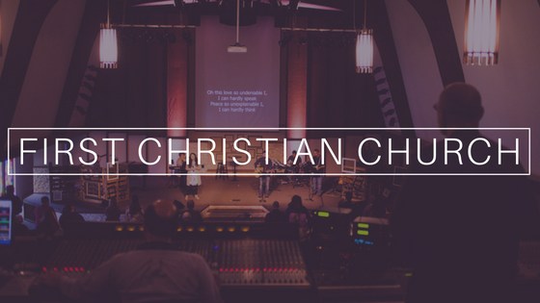

Hey Elizabeth!

I’m so glad that you are interested in being involved with the worship ministry. We are a growing team, committed to developing our hearts and our skills to bring honor and glory to God. Being on the team isn’t just about Sunday morning; worship is much more. Our gatherings every week are an overflow of our love for God and for people each day. We aren’t perfect, but we are trying to live out worship daily. I’m glad you are joining us.

On the next page, I’ve outlined some basic things you’ll need to know, basic expectations, and given a few details on a study called Pure Praise that you’ll begin reading soon. If you ever need anything, you can always reach out to me or any person on the team.

I’m looking forward to singing together on Sunday mornings, and I’m looking forward to growing together in our love for the Lord.

Serving Him,
Jordan
Stage Presence Tips by Dawn Kelley

When we lead worship, we are in a conversation with God and with others. In a typical conversation, the nonverbal ways we communicate to emphasize what we say verbally - smiling, eye contact, physical touch - are usually expressed naturally. Being on stage though, with the physical distance between the worship leader and worshiper, the ability to communicate verbally and non-verbally drastically diminishes. To help with the verbal part, we use microphones. To help with the non-verbal part, we must make our movements intentional and noticeable; keeping in mind, the goal is not to perform but to clearly communicate the Gospel with excellence unto the glory of God. So, below are a few ways we can increase the “volume” of our non-verbal cues without being a distraction.

- Smile. Our smiles reflect the privilege and the joy of being able to worship God together. Obviously, don't smile during a somber moment, but smile at the very beginning of a service when being introduced or during a joyful song. Hold your smile a few seconds so everyone in the room - even those in the back - have a chance to look, focus, and see that what is about to happen is going to be good, not bad. You don't have to show your teeth but do include your eyes in your smile. If you are concerned about looking fake, you won't as long as putting others at ease is your goal.
- Sing and play to the people in the back of the room. Make eye contact with the people in the room - not too long or you'll make them uncomfortable - but look at them, acknowledge them, notice them. If you're an instrumentalist, look up from your instrument or music periodically, and sing along with the worship leader. We want to make sure even those who are the furthest from us physically still feel included; like they can engage and participate in the ongoing worship dialogue together.
- Move to the music a little more than you're comfortable with. Let's face it, most people feel uncomfortable on a stage, but our non-verbal cues diminish greatly from 10-20 feet away. So, we need to think about "over communicating" towards being uncomfortable with ourselves especially if we are naturally reserved. It will feel unnatural at first, but a slight movement most likely will not be noticed by someone in the front row. Move your body to the rhythm especially if you're an instrumentalist. Singers, if you're uncomfortable with clapping, try moving your hands periodically to emphasize the lyrics. If the lyrics are more prayerful or reflective, simply clasping your hands at your heart can highlight the intent of the song. When raising your hands, extend them a little higher over your head or further out in front of you. Just make sure not to hit anyone near you. I've done this which, during a happy song, gave me another reason to smile.
- Nod in agreement when someone speaks. Nodding helps offer non-verbal commands for the congregation's attention and goes a long way in backing each other up on stage. Nod slowly, especially if you're further from the front of the stage. Also, looking and slightly turning their way when someone else speaks or sings "tells" the people in the room where their attention needs to be given.
- Practice in your mirror as often as you practice your music. Usually when I'm on stage and think I'm smiling enough, I'm not. It's not until I watch a video and see my smile didn't even show up on camera and several times, I looked angry. But when I practice in a mirror, I can visually see and physically feel the facial muscles I need to engage simultaneously. I can see when I'm furrowing my brows rather than raising them. I can feel how wide my smile needs to get in order to reach my eyes. I can see if I have bad posture while playing. Then when I'm onstage, if I feel different than what I've practiced, it will be a physical reminder for me to think about the nonverbal communication I am sending to others.
Hopefully these tips will help us clearly communicate the message both verbally and non-verbally.
Grace Baptist Church Worship Team
“Sing to him a new song; play skillfully, and shout for joy.” Psalm 33:3
The culture of worship at Grace Baptist Church comes from a unified response to God’s presence and a desire to worship to an audience of one. Our desire as a ministry is to build a community of singers, and musicians who use their time, talents and treasures to passionately lead others into a place of intimate worship. This mission is more important than the music itself and is an essential part of GBC’s culture.

General Requirements:
Here are some things we can expect from each other as Worship Team members:
• A passion for worship primarily and music secondarily
• A positive / team player attitude
• A strong, energetic stage presence
• A correctible and teachable spirit
• A strong dedication to personal spiritual growth

Prayer: Hebrews 10:23-25 As a team our goal will be to stir each other up to prayer. While we understand that we cannot be constantly bowed in prayer we will still attempt to have an unceasing prayer conversation with God and will make prayer the center point for our worship.
Practice: 1 Chronicles 25:7 Each person needs to understand in their own mind that being a part of the team means we will be in an ongoing process of being trained. We cannot expect anyone to be perfect overnight and we will realize to serve is to lead and that comes with greater expectations.
Attitude: Matthew 22:37 As we face hardships as a team, we will remind each other that we are not always in control. We will need to keep each other accountable with both our character and our actions.
Flexibility: Philippians 4:12-14 We will each understand that sometimes change is hard, but we will aim to be flexible and adopt an attitude of anticipation. We will keep in the back of our minds that nothing gets better without change. We will welcome change as an opportunity.
Servanthood: 1 Corinthians 12:18-19 We need to remember we are all born with different gifts. Each person serves as different parts of the body. God gave us each a gift and He has a place and a job for each of us that He wants us to do.
Punctuality: Ephesians 5:15-16 Each of us will strive to respect the other people’s time on our team. We will strive to remember that the stated time is the official START time and we will aim to arrive early and be set up. We will all be flexible and understand that life happens. Strive to arrive.
Unity: Colossians 3:13-14 We must remember to bear with one another. God placed us on this team to grow with each other and we must be willing to forgive one another. We will attempt to work together to grow and strengthen our team.

Final Thoughts
I am very excited that each one of you is a part of the Worship Arts ministry at GBC. I am excited to see what God has in store for all of us as we continue to grow closer together and can worship him each Sunday morning from the platform. I pray that none of us would ever elevate each other but that we would remember that we are a team, and we would encourage each other and grow together. There will be hard times ahead, but we must stick together as a team and continue to keep our focus on Christ.

More than the Music!
~Chris Mellon

CHOIR PROCESSES

TEAM VISION

At Sample Church choirs have always been important and continues to be. Worship-leading choirs can be found several times in the Old Testament, so choirs are a biblical idea, and not merely a church tradition. Our children’s choirs and our adult worship choir are both vital because they give people an outlet to use their voices to lift worship to God. They also play a huge part in helping to train our members about worship and worship leading.

TEAM ROLE

We define “worship choir” as a large group of worshiping singers who support the band and lead vocalists; they encourage participation through their skilled singing and enthusiastic presence; they occasionally sing anthems and featured specials; however, they do not sing on every song or in every service.

Always leading. When the worship choir isn’t scheduled to lead on the platform,
our choir members lead from the congregation and sit/stand with their family or
those they’ve invited

Not your typical choir. Our worship choir stays primarily on melody on
congregational songs. Why? Because we are carrying the melody of our church!

One Voice. We say “we” and not “they” when we refer to our choir. We try to
show love, respect and support toward our worship staff and choir leaders. A
team spirit/mindset is vital to us. Thus, we always speak well of the choir and of
our leaders. We want to help others see why we do what we do and what we are
trying to accomplish in the choir.

Choir leaders. Our worship choir has certain people who are our leaders in that
they serve the choir as hosts, captains, managers and conductors.

Always growing. We encourage our choir members to join a Life group within our
church so they can grow deeper in God’s Word. The choir is not a Life group.

WHEN WE SING
Our worship choir rehearses every Sunday evening from 6:00pm until 7:15pm.
We sing on the platform two Sunday mornings per month, on average. On days
we sing on platform, we meet at 8:00am for warm-up, instructions, prayer and
sound check. We usually take time off in summer from rehearsing and singing on risers.

Singing twice a month, rather than every week, is very important for several reasons:

1. We have more time with family & friends on Sundays when we aren’t singing

2. We lead in worship with more excellence and effectiveness because we
rehearse twice as often as we sing

3. Not singing every week gives us more variety in the service elements and
leaders we use week to week

4. Singing out among the congregation encourages them to sing as they
hear us sing near them. Plus, we can listen for good voices around us and
invite them to sing in the choir.

HOW WE COMMUNICATE
Planning Center Online (planningcenteronline.com) is the primary source for adult
choir members to access songs and music files and see upcoming service orders
and choir singing schedules. Choir members receive an emailed invitation to log
on to Planning Center.

Our private Facebook page is a good place to share prayer requests, announcements and updates
specific to the choir. New choir members are usually granted permission to access the page within a
few weeks of joining.

WHAT WE REQUIRE
While we are ALL imperfect and in need of new mercies every day, due to the fact
that the adult worship choir leads from the platform, we require that you not
participate in activities that would give reason for people to question your
leadership or position as part of one of our most visible volunteer teams.

Understandably the bar is set high, as we have the privilege of helping bring the
manifest presence of God to those in our congregation. Thus, it is a position of
leadership that we take very seriously. Therefore, if at any time we have reason to
question your personal standards and practices, we will not hesitate to address
the matter with you, taking biblical steps as needed.

Application for Choir

Contact Info

Name:_________________________________________________________________

Address:_______________________________________________________________

Email:_________________________________________________________________

Cell phone:____________________ Home phone:____________________________

Facebook:_____________________ Twitter name:____________________________

What are the best ways to communicate with you? Email, text, Facebook, or other? _________

Personal Info

1. Please tell why you wish to join the worship choir.

_______________________________________________________________________

_______________________________________________________________________

2. Are you a member of this church? Yes No

3. Have you sung in other choirs or choral groups in the past? What is your background in music?

_______________________________________________________________________

_______________________________________________________________________

4. What part(s) do you sing? Circle what applies: soprano, also, tenor, bass

5. Do you play other instruments? If so, please list them and tell us how long you've been playing them.

_______________________________________________________________________

_______________________________________________________________________

6. Have you ever worked with production in a church before--running sound or video, for example?

Yes No

7. Please briefly give us your testimony of when and how you came to trust Christ as Savior.

_______________________________________________________________________

_______________________________________________________________________

_______________________________________________________________________

_______________________________________________________________________

8. Have you served or are you serving in other ministries in our church or in other churches or ministry
organizations? Yes No If yes, then what are those ministries? _______________________

9. Please list 2 references (name, phone#, email) – Family, co-workers, pastor, etc. (not relatives) &
please state their relationship to you:

________________________________________________________________________

________________________________________________________________________

----------------------------------------------------------------------------------------------------

At Sample Church, it is an honor to serve in any manner, as we represent Christ
and serve as extensions of this church. While we believe God loves all people and that His
grace is offered to everyone regardless of his or current lifestyle, we want those who help
lead our congregation to model the highest lifestyle standards as reflected in Scripture.
We believe Scripture establishes God’s requirements for leaders and that we will be held
accountable for those we approve to lead our congregation.

Therefore, if you are a participant in any of the following lifestyles, we ask that you not
apply to serve or lead in the VVC choir:
Engaged in a sexual relationship outside of marriage
Participating in a homosexual relationship
Engaged in an extramarital affair
Public or excessive alcohol use
Illegal drug use
If you have concerns, questions, or feel that the guidelines above disqualify you from
serving, please contact our staff team and we will be glad to talk with you.

What Our Worship arts ministry Expects of Choir Members:

1. To attend on average a minimum of 3 out of 4 rehearsals*

2. To sing with the choir in worship services a minimum of 3 out of 4 times.

3. To be supportive of our pastor and involved in the life of the church.

4. To seek to grow as a worshiper of God and become more like Jesus.

*Exceptions may be made for extenuating and understandable circumstances.

What Choir Members Can Expect from Our Worship arts ministry:

1. To be prepared and intentional with leading rehearsals so as not to waste anyone's valuable time

2. To lead the choir with enthusiasm and excellence during worship services

3. To support the vision and leadership of our pastor and elders

4. To be godly leaders who care for those involved in our worship arts ministry and seek the Lord's
direction for our ministry

I, ______________________, hereby promise to try to meet the expectations for choir
members that are listed above. Furthermore, I give Sample Church the right to
investigate all references. I also recognize and affirm that Sample Church may
conduct a criminal background check and understand that the results obtained will be
used in determining my eligibility to serve in this ministry. I hereby release Sample
Church and its representatives from liability for seeking such information and all other
persons, corporations or organizations for furnishing such information.

Signature:_____________________________________ Date:____________________

Thank you for completing this application! Please give it to one of our worship staff
members, to a choir captain, or bring it by our church office. You can also scan and
email this application to: _____________________. (Please put "Choir Application" in
the subject line when you email.)

NOTE OF INTEREST: Interviews for new choir members will take approximately 10
minutes in length. Please allow 30 minutes as a buffer. Interviews are held immediately
after choir rehearsals on Sunday evenings. Scheduled appointments are preferred but
not always necessary. To schedule an interview, please contact a worship staff member
or choir leader.

We will try to contact you within the next few days to follow up with you. Completing this
application does not guarantee membership in the Adult Choir. An interview
is still needed to become a Worship Choir member.

----------------------------------------------------------------------------------------------------

OFFICE USE ONLY below this line:

INTERVIEWED BY: _______________________________ DATE: _____________________

References:

Interview:

Vocal scale:

Choir Manager Role Description (for Sunday mornings)

Key Responsibilities:

As a Church Choir Manager (CM), you oversee managing the choir in the church gatherings for which you are rostered. Your leadership of this team involves the following:

1. Bringing leadership to the choir and working with the Choir Conductor (CC) to
ensure the choir’s involvement in the worship gathering is effective. This involves,
but is not limited to:
a. Ensuring the choir is given clear direction
b. Ensuring that choir placement optimizes presentation
c. Working with the CC & production about where the gathering is headed
and what direction choir will need (i.e.. Changes to normal loading/unloading
process for risers, seating, communion, etc.)
d. Ensuring that you are discreet in the functioning of your role and that your
leadership results in choir having clear communication and all the direction
they need for that gathering.

2. To follow up with CC regarding areas of the gathering which need improving so
that they can provide any necessary feedback to the choir oversights.

3. To give feedback to the CC and choir on:
a. Vocal ability and areas to work on
b. How they work with each other (blend, following conductor, team dynamics)
c. How they communicate to the congregation (stage presence, energy, etc.)

During the Week
Confirm (or decline) your rostered position on Planning Center as early as possible
Be communicating with the CD and CC of your rostered gathering about that gathering

Pre-rehearsal Warm-up
Be early to warm-ups and ensure that warm-ups start on time. Bring leadership in
the event of the CD, CC or person leading not being present (come prepared with
ideas—I.e., Warm-ups, prayer, stretching)
Go through song maps with choir of when to sing and not to sing
Lead the choir in a time of prayer prior to coming upstairs for rehearsal with band
Ensure that warm-ups finish on time and communicate with the CD or CC of
when to direct choir to the sanctuary for rehearsal prior to the service
Pick up a run-sheets from production or download in advance from Planning Center

Rehearsal
Assist CD or CC in directing choir to load the stage
Arrange choir in vocal sections first (altos, sopranos, tenors, basses)
Arrange choir in order to best suit the risers and look of the platform
o Consider height/hair/color of tops and shirts
Assist the CD or CC so they can address any side of stage needs (monitor levels, etc.)
Be sure choir sings at normal levels for sound checks
Be familiar with the dress code and address any dress code issues (please do so
discreetly and with grace)
Help choir to feel comfortable – lead them with love
Observe choir during rehearsal from near and far. Bring feedback, swap people
around (only if necessary), etc.
Be available to answer any questions that people in choir may have
Communicate with the stage managers to ensure that you have all the information
you require for that gathering (i.e., when and how choir will unload risers, alteration
to order of gathering, set changes, etc.)
Stay with the choir to build relationships
Be encouraging people to come on in for warm-ups and upstairs for rehearsals on
Sunday mornings
Remind choir of housekeeping items (palm claps, feet planted, keeping eyes
open, watching CC or CD, staying engaged, heads toward mics, etc.)

During Gathering (service)
Assist CC or CD to ensure choir unloads the risers and stage at the right time
If the choir is to return to the risers later in the service, be the point person for
production and behind the scenes changes
Manage the noise level backstage (in the hallway) as choir is waiting to load (or
re-load) risers; have everyone ready
Ensure choir loads back on quickly and quietly

We want you to be inputting into our team – helping them to grow and step up in ability
and leadership. As a leader, be present and active—even when you aren’t rostered, and
when possible, join the team for prayer and be actively building relationship. Our
expectation is that first and foremost the most important thing to you is your relationship
with God. We want you to be healthy—physically, emotionally and spiritually. You are a
valuable part of our team, not because of what you do, but because of who you are. If
there is ever a time that you find yourself in an unhealthy position or struggling with your
role, please reach out to our worship staff. We genuinely care about you and want to do
everything we can to help.

Choir Conductor Role Description

Key Responsibilities:
As a Church Choir Conductor (CC), you oversee bringing leadership
in worship to the choir in the church gatherings and during rehearsals as needed for
when you are rostered. Your leadership of this team involves the following:

1. Bringing leadership to the choir and working with the Choir Director (CD) and
Choir Manager (CM) to ensure the choir’s involvement in the worship gathering is
effective. This involves, but is not limited to:
a. Ensuring choir is given clear communication and leadership throughout
rehearsal and the gathering.
b. Ensuring the sound output of choir is excellent and when it isn’t, drawing it out
of them
c. Working with the service quarterback (QB) about where the gathering is
headed and what is needed from choir
d. Ensuring that choir is working as one unit and are ultimately communicating
passion and heartfelt worship to the congregation

2. To give feedback to the choir on:
a. vocal ability and areas to work on
b. how they work with each other (blend, following you, team dynamics)
c. how they communicate to the congregation (stage presence, energy, etc.)

3. To follow up with CD regarding the gathering and communicating to the QB
about any areas that require further training.

During the Week
Confirm (or decline) your rostered position on Planning Center as early as possible
Download the song list from Planning Center for your rostered gathering and
ensure you are very familiar with the songs
Be thinking about what you might wear. Often, the conductor’s back is facing the
congregation most of the gathering, often in the QB’s TV shot. Ensure you
have clothing that will cover your bum and not draw attention to yourself.
Remember that modesty is the goal.
Be communicating with the CD about your rostered gathering

Pre-rehearsal Warm-up
Be early to warm-ups and if rostered to lead them, come prepared with a
minimum of 10 minutes of vocal exercises and desired outcomes
When directed by CMs, make you way to the sanctuary and go straight to the platform
Help the CM as needed to go through song maps with choir of when to sing and not to sing.

Rehearsal
Be talking to the choir throughout rehearsal and communicate your desires (i.e.,
entries, cut-offs, dynamics, timing, etc.)
Remind choir to be watching you (or the CD if he is always conducting) and to
be communicating with their face and body language as well as their voice
Ensure that your signals are clear and can be seen by everyone
Make notes on songs indicating any necessary information that you will need (i.e.,
song structure, entry points, etc.)
Know where you want to go and be confident in your leadership
Ensure that in your leadership you are bringing joy, passion and love—remember
that choir will follow as you lead
Encourage choir to watch and learn during times that are idle—too much talking
between songs is distracting for the rest of the team
Be around the choir after rehearsals talking to people and building relationship

During Gathering (service)
Be full of life and energy
Be confident in what you’ve rehearsed
Bring clear & confident leadership
Ensure you are watching the QB and looking for their directional cues
Ensure choir is engaged and bringing leadership before, during and after the
praise time. Choir should be watching the pastor or whoever is speaking (if they’re
still on the platform), praying (with hearts but not audibly), during prayer moments
and promptly and quietly leaving the platform as directed

We want you to be inputting into our team – helping them to grow and step up in ability and leadership. As a leader, be present and active—even when you aren’t rostered, and when possible, join the team for prayer and be actively building relationship. Our expectation is that first and foremost the most important thing to you is your relationship with God. We want you to be healthy—physically, emotionally and spiritually. You are a valuable part of our team, not because of what you do, but because of who you are. If there is ever a time that you find yourself in an unhealthy position or struggling with your role, please reach out to our worship staff. We genuinely care about you and want to do
everything we can to help.

Practical Tips
Think ahead of the beat
Anticipate giving cues for melody, parts, dynamics
Standard hand signals (melody/parts/quieter/NOT singing/MORE)
Reflect what you want reflected
Clean/sharp movements
Cut off’s and as much as possible give cue to come in
Parts (a general idea of what PART to sing and who sings them)
Anticipating what is coming up next (instrumentation/bridge, etc.)
Make sure you have enough CLICK track, lead vocals, keys and acoustic
Lead by worshiping
Trust the musician in you

Leadership Roles Descriptions

All choir leaders have the following responsibilities:

1. Lead in the following ways:
a) Singing (listening, learning, practicing)
b) Section (leading particularly within your own section)
c) Shepherding (hospitality, caring, follow up)
d) Systems (promptness, processes, positive attitude, flexibility)
e) Spiritually (growing, participating in studies, leading devotionals)

2. Meet 1st Sunday evening of every month at 5:00pm for prayer, updates & fellowship.

3. Be at evening rehearsals 15 minutes early to welcome and greet.

4. Attend rehearsals and services faithfully and enthusiastically!

Hosts
Help shepherd those within your choir section and others in the choir
Follow up with people who develop a pattern of not attending rehearsals or
singing in services
Arrive early before rehearsals
Be pro-active by going up to people as they arrive, greet them, etc. (Don’t just
check them off.)
Greet everyone (don’t just talk with people you know)
Send out rehearsal and weekend or choir related reminders, as needed or
directed for those—especially for those in your section who don’t read email or
Facebook
Help captains as needed with attendance/role taking
Be leaders of singing by learning your music and being prepared as much as
possible when you come to rehearsals and sing in services
Attend monthly leaders meeting (1st Sundays at 5:00pm)

Captains
Assist the managers and hosts with systems of attendance & follow up
Print out attendance sheet before/upon arrival. Give and collect sheets from
section hosts.
Arrive early before rehearsals
Be pro-active by going up to people as they arrive, greet them, etc. (Don’t just
check them off.)
Upload attendance data within 48 hours of rostered dates into Church Teams
Be in place to greet & welcome people before call time
Greet everyone (don’t just talk with people you know)
Welcome and make people fee at home
Be leaders of singing by learning your music and being prepared as much as
possible when you come to rehearsals and sing in services
Oversee interview process with new choir members (to be sure it gets done!)
Attend monthly leaders meeting (1st Sundays at 5:00pm)

Managers
Facilitate the flow of regular rehearsals and of pre-service rehearsals.
Give leadership and direction to overall rehearsal and Sunday morning choir
involvement.
Download run sheets from Planning Center each week
Coordinate schedule with other manager(s) about who is in charge when.
Be pro-active and bold
Be assertive
Cue person with the next responsibility
(before rehearsal) Communicate with those designated to lead icebreakers,
prayer, announcements, devotionals, etc., making sure everyone understands
their notes and what needs to be executed
Call/text choir leaders if they don’t arrive 10 minutes after start time
Oversee prayer request cards and prayer requests during rehearsals
Oversee ministry to members during deaths or tragedies in their immediate
families
Lead monthly leaders meeting (1st Sundays at 5:00pm)
Put out water & refreshments on Sunday mornings in choir room; then put back
into filing cabinet (in drama room)

Music Director
Oversee music preparation, and availability
Be sure music is copied, placed in music bins, and ready for rehearsal
Schedule and oversee musicians needed for rehearsals and Sunday morning
warm-ups
Prepare weekly rehearsal run sheet and post on Planning Center by Friday of
each week for the assigned choir manager and captain

Conductors
Choir conductors help the choir director lead selected songs during choir
rehearsals and sectionals.
Conductors assist the choir director and service quarterback as needed to cue
and lead the choir during Sunday morning services.
When cueing the choir during services, it’s best to be discreet with congregational
songs where a main leader and/or vocal team is leading the song. However, it is
generally good to be more animated and energetic when leading choir specials.
Think ahead of beat
Anticipate giving cues for melody and parts
Standard hand signals to lead (For example, NO singing)
Reflect what you want to see reflected (smile and look pleasant)
Clear/sharp movements
Cut offs and as much as possible, give cues to come in
Parts (a general idea of what part to sing and who sings them)
Anticipate what is coming up next (instrumental, bridge, etc.)
Trust the musician in you (but more importantly, the Holy Spirit in you)
Make sure you have enough CLICK track, lead vocals, keys and acoustic in your
in-ears
Lead by worshiping
When rehearsing songs, patiently but firmly encourage the choir to focus and
listen. If choir members are talking excessively, it may be necessary at times to
politely ask them to stop.
When rehearsing songs, try to maintain a positive and loving spirit and attitude,
which will almost certainly “rub off” on the choir and help create a fun and
productive atmosphere.
Attend monthly leaders meeting (1st Sundays at 5:00pm)

Church Choir Attire

Below are general guidelines for how we dress in the worship choir. Modesty is the
key—on and off the platform.

What to wear: Casual, solid colors, darker colors preferred

Tops
Avoid t-shirts. Please no sports logos, large graphics or logos or large brand names.
Avoid tank tops, low necklines, cleavage and tops that don’t cover shoulders
Tops/shirts can be loose fitting and not too tight
Tops/shirts must be long enough to cover midriff
Ladies, avoid white/cream/light colored tops, unless very loose fitting

Bottoms
Jeans/slacks/capris are OK. Be sure they are presentable with no big rips or holes
please
No shorts
Ladies: black/dark leggings/jeggings acceptable if top/dress/skirt is at
the knee. Hose do not count
If wearing a skirt or dress, a slip, leggings or jeans should be worn underneath
If wearing tighter skinnies, please be sure to cover your bottom
Please refrain from skintight skinnies/pantyhose (as leggings)/fishnet

Shoes
Closed toe shoes preferred
Peep toe flats/wedges & sneakers are OK
No thin heels/stilettos
If wearing open toe shoes, we will not be held responsible for any injuries that may
occur from on something while on or load/unloading the risers and platform
We realize some may want to take their shoes off at times because they feel
they’re standing on “holy ground.” We do not prohibit this. However, we do
discourage it for choir members on risers for two reasons: 1) It’s easier for your
feet to get injured when not protected with shoes, and 2) the resulting unpleasant
aroma may cause your choir neighbors to have unholy thoughts toward you.

Other dress standards to please note:
Please no tight fitting or low-cut skirts (guys and girls), armpits/shoulders on show,
underpants on show from sagging jeans, alcohol brand name t-shirts, and secular
brand t-shirts
Off the stage, if wearing leggings/jeggings/tight skinnies, please consider wearing
tops that cover your bottom.

Thanks so much for your cooperation. If in doubt, bring a spare set of clothes and ask
the choir managers. This choir attire is not a suggestion, but a standard that we will
uphold. Please do not be offended if asked to change your clothing.

Worship Choir Soloists and Special Ensembles

1. Soloists and special singers are generally chosen from people who are involved in
our worship arts ministry in some way.

2. Soloists who sing for a special song on special occasions do not have to be
apprentices or leaders in our ministry. However, they do need to qualify as
worshipers in our ministry. By “worshipers,” we mean they have shown
themselves to be faithful to ministry involvement and church attendance. They
have demonstrated that they are growing in their faith and in their knowledge of
worshiping God with their lives.

3. Soloists and ensembles are chosen based on their talent and skill level. They must
be able to sing confidently on pitch and have good stage presence. To sing in an
ensemble, they must be able to harmonize. Breath support, diction, phrasing and
dynamics are also very important.

4. The worship staff chooses who will sing solos and sing in ensembles and when.
We try to match people with songs that would work best with their voice and
singing style.

5. The worship staff will try to give sufficient notice to soloists and ensemble singers,
so, they can practice and prepare as needed to internalize their songs.

6. All soloists must memorize and internalize their songs, so they can “own” the song
and properly present it to the Lord and to the congregation.

Worship Choir Auditions

1. We occasionally hold auditions for soloists and ensembles. These auditions are
generally, not for a specific song, but rather for the opportunity to sing on future
songs as needed and determined by the worship staff.

2. Worshipers who would like to be considered for a solo, duet or ensemble are
welcome to let the worship staff know of their desire to sing.

3. It should be noted that one’s goal should not be to get to sing a solo or be
featured in some special way. There is certainly nothing wrong with singing solos.
However, one’s heart and attitude as a worshiper should be like Christ’s—to serve
others and prefer others over ourselves. Be content to sing in the choir or serve
unnoticed in the tech booth, patiently waiting until and if an opportunity comes
along to use your talents in some special way.

Worship Leaders & Choir Soloists

Worship Leaders are selected leaders who hold microphones and sing the “lead” part of
one or more songs during our services. Worship Leaders help to lead our congregation in
praise and make transitions between songs from week to week. To serve as a Worship
Leader one must first be a worshiper and an apprentice in our “funnel” process of
development. Our worship staff, as needed, chooses Worship Leaders. We do not hold
open auditions for WLs. Worship Leaders must sign our Worship Leader Covenant
(below).

Worship leaders rehearse with the band on Tuesday nights when they are scheduled to
sing. If their song involves choir help, then worship leaders should rehearse at least once
with the choir on a Sunday night.

Choir soloists are choir members who have good stage presence and exceptional vocal
skills. To be a choir soloist one must first be a worshiper in our “funnel” process of
development. Our worship staff chooses soloists as needed. We also hold auditions for
choir soloists from time to time. You can also request an audition.

Singing in the choir is not a requirement for being a Worship Leader at Valley View
Church: however, we do prefer that Worship Leaders sing in the choir whenever
possible. We never want to give the impression that vocal team members are special
"Personalities." We are all part of the same worship arts ministry team. Thus, when we
are not assigned to sing on mic, we need to be in the choir supporting them and singing
from the risers as much as we can. It's especially important to participate during special
occasions like White Christmas, when more singers are needed in the choir.

Reasons why we don't require Worship Leaders to sing in the choir:

1. Multiple ways to serve. The choir is a huge part of our worship arts ministry, but
it's not the only way one can serve. People can also serve in our tech booth, in
children's choir, in creative ministry, in high school and middle school bands, in
benevolence opportunities, and in other areas both inside and outside our worship
arts ministry. Before one is selected to serve on the vocal team, he or she must
serve in one of our other areas of ministry for a period, to demonstrate his
or her servant's heart as a true worshiper.

2. Time restraints. Vocal team members can't always attend both choir rehearsals
and Worship Leader rehearsals, both of which take a great deal of time. Some
vocal team members also play instruments, which takes even more time for
rehearsing.

3. Vocal style & timbre. Some people's voices don't blend well in a choir. Their

voices are uniquely suited for certain styles, and they tend to do well as soloists
with certain songs, but not with harmonies and with singing in a group.

4. The Vocal Team is not an extension of the choir, and the choir is not the funnel
through which everyone must pass in order to be a Worship Leader. Choir is one of
several teams that make up our worship arts ministry—as are Worship Leaders.
Nonetheless, it should be noted that choir is the best way to prepare for the
possibility of serving on the Vocal Team. Singing cheerfully and faithfully in the
choir can help the worship arts staff become aware of your gifts and vocal skills
and of your servant-heart.

Worship Leader Qualities

Vocal Quality (Strength, clarity, pitch, support, timbre/tone)
Harmonizing ability (easily finds a part, carries it alone, listening)
Stage Presence (expressive, authentic, outward, inviting, confident, humble)
Song/band leadership (skill to communicate, to command, to flow, to succeed)
Sensitivity (to the Spirit, to the people, to the band and tech, to flexibility and planning)
Personality (kind, caring, reliable, servant, cooperative, team player, not easily offended)
Apprentice or lower in our Development Funnel (growing spiritually and in leadership, song
preparation, active in our church, attends worship training opportunities)
Commitment to the team by signing the Worship Leader Covenant (below).

Worship Leader Covenant

I have read and agree to follow the Worship Leader Handbook.
I will attend monthly Worship Leader Conversations.
I will continue to learn and grow in my musical skills and in my ability to lead others in worship.
I will maintain a regular quiet time with God.
I will pray for the other worship leaders and members on our team.
I will support the choir and sing in the choir when needed and possible.
I will respect and support my worship team coaches and quarterbacks.
I will seek and pray for unity, health and growth within our worship arts team and church.
I will say “we” rather than “they” when speaking of the worship ministry.
I will help to develop other leaders within our worship ministry.
If and when I leave the worship arts ministry and church, I will speak well of this church and will try
to make the most of what I’ve learned while in this ministry.

___________________________ _______________________ ______________________
Worship Leader Worship Pastor Date

Children’s Choir Director

Oversee the Children’s Choirs under the Worship arts ministry
o Be a liaison between the Worship Pastor/ministry and the children’s
leaders/choirs

Supervise Children’s Choirs Wednesday Coordinator
o Planning, supervising leaders, and weekly events
o Communication with Parents, issues, schedule

Supervise Children’s Drama Director
o Planning, auditions, scheduling rehearsals, tech needs
o Set design, costumes and props

Model and train leaders to love children and teach them to worship God through
music and the creative arts

Maintain budgets, P.O.s, calendar and all facilities related to the choirs.

Encourage children and their families in developing music and dramatic talent
o Celebrate the opportunities of success leading in worship
o Share life and experience with the children.

Children’s Choir Director Checklist

Before Fall Start Date: (Aug)

1. Oversee curriculum, supplies
2. Order music for Celebration Singers
3. Set up facilities, room assignments, event forms

August:

1. Train Coordinator on Church Teams, tracking attendance
2. Train leaders and assistants on curriculum and discipline
3. Ask office ladies to make Enrollment Cards and Choir Folders
4. Update Background checks

September:

1. Send out beginning of year letter and calendar
2. Plan singing dates for younger choirs for calendar and notify worship staff
3. Order crafts for the semester
4. Compile Parent Volunteer list with Coordinator
5. Tryouts for Christmas parts/cast list/extra practices scheduled

October:

Start finalizing plans with tech/staging for Christmas program

November:

1. Mail letter to parents for Christmas program/dress rehearsal details
2. Dress rehearsal plans/tech list
3. Order of Worship
4. Bulletin for program
5. Announcement for program in Sunday am bulletin
6. Postcard for younger choirs (coordinator)
7. Plan Christmas parties/shop (last choir night) and Cast party (Celebration Singers on Sun)

December:

1. Buy snack for dress rehearsal and parties
2. Supervise Christmas dress rehearsal and program
3. Order spring music for Celebration singers
4. Thank you cards

January:

1. Plan singing dates for the younger choirs and notify worship staff
2. Run spring calendars and pass out at choir
3. Order crafts/check folders and supplies
4. Information for the KBC All State Children’s Choir passed out to 4-5th grade
5. Set up practices and audition date for All State
6. Tryouts for spring parts

February:

1. Spring cast list/extra practices scheduled
2. Tryouts for All State/coordinate with tech

March:

1. Extra practices for All State
2. Chaperone/All State plans/registration

April:

Start finalizing plans with tech/staging for spring program

May:

1. Mail letter to parents for spring program/dress rehearsal details
2. Dress rehearsal plans/tech list
3. Order of Worship
4. Bulletin for program
5. Announcement for program in Sunday am bulletin
6. Postcard for younger choirs (coordinator)
7. Plan/shop spring parties (last choir night)

May/June:

1. Supervise spring dress rehearsal and program
2. Confirm leaders and assistants for fall with coordinator
3. Thank you cards/notes to 5th graders
4. Plan new music for fall

Children’s Choir Leader’s Qualities

Heart for Children
Desire to see children express their love for God
Desire to nurture and invest in our children at VVC

Love for Music
No professional training needed
Teach age-appropriate ways to understand music and use it to worship the Creator of music

Commitment
Wednesday nights 6:15-7:45pm
Schoolyear:
o August – December (off same as JCPS)
o January – May (offspring break and summer)
Prepare specials for Wednesday night worship:
o One song each semester
Prepare songs for Programs (Christmas and Spring):
o Usually 3 songs
o Bible Verses, etc. between songs optional

BANDS PROCESSES

TEAM VISION
We use multiple bands to lead our various services and gatherings each week.
Our worship bands are vital to the corporate worship experience.
We encourage opportunities for musical and spiritual growth and for fellowship
and community within our bands. Our goal is to help our band members balance
their time at church between playing music and being with their families.
Therefore, we rotate band members weekly to allow time for both.

TEAM ROLE
We serve diligently to support our vocal team, lead singers, choir and pastors.
With our serving, guests can enjoy stylistically pleasing music and to be
drawn more easily into an experience with God in a unified worship environment.
We are charged to play with humility and enthusiasm, while maintaining a spirit of
excellence and authenticity.

Enhancing the worship experience. We have the honor of enhancing the
Spirit-filled environment of worship in our church through making music and
providing accompaniment for the psalms, hymns and spiritual songs our church sings.

Seen as well as heard. People not only listen to us play but they also watch us
as we play; thus, we strive to internalize our music so we can think more about
the words and focus more on worshiping God ourselves.

TEAM RESPONSIBILITIES
Prepare in Prayer. Pray God’s heart for His people each time you
serve. Ask God to move in a special way – to personally touch hearts and heal
wounds and bring His lost children home. Pray for the specific, personal moment
of intimacy with Jesus that would forever change people’s lives.

Serve when scheduled and contact Corey or Music Director when you need a
replacement. Communication is crucial for building community and carrying out
effective ministry, so please let us know your availability to serve.

Be on time and ready to rehearse. Arrive in enough time to set up your
instrument and tune it BEFORE rehearsal begin. Be sure to let us know as early
as possible when you see you can’t attend a rehearsal or service you’re scheduled for.

Listen to the pastor’s sermon. We expect every band member to sit in the
congregation and listen to one of the pastor’s messages each Sunday. We do this
not only for our own spiritual nourishment, but also because we want to set an
example for others to follow. We are participants in the entire service experience—
not just the music part. Teaching and preaching from God’s Word is a vital part of
our worship services.

Serve with heart, commitment, and excellence. We want you serving in your
gifts and passions—in ministry that is an overflow of love and enjoyable to you. If
this ministry is not a fit, if you would like to investigate a new ministry team, or if
you need a break from serving for a season, do not hesitate to let us know. This is
one reason we are here – to walk through life with you!

Practice your music at home. Rehearsals are not the place to figure out a new
guitar riff or learn to play a difficult rhythm part. Hone your skills and knowledge at
home before you come to rehearsal. Listen to the song demos, and be as ready
as you can to help us recreate (and sometimes reshape) the songs.

Trust the sound operator. Once you get a good sound check with your
instrument during rehearsal, then leave it alone. Don’t change the volume or how
you play during the actual service. Play with the same volume and intensity you
did during rehearsal. Trust the sound person to handle the sound out in the house.

Smile and be happy. You are serving the Risen King and His Church! “For the
ministry of this service is not only supplying the needs of the saints but is also
overflowing in many thanksgivings to God.” (2 Corinthians 9:12 ESV)

PLANNING CENTER

Planning Center Online (planningcenteronline.com) is our main source of
information regarding scheduling, service flow, communication between team
members, and service times, song demos and music files. You have access to
this via web browsers and mobile devices.

At Sample Church, we do not require that you serve every week, but we do
ask that when you receive this invite to serve, please respond in a timely manner
so that we can ensure your instrument and part is filled for the service.

Bands should receive rehearsal song list via PC a few days before rehearsing.

Application for Bands & Worship Leaders

Contact Info

Name: _________________________________________________________________

Address: _______________________________________________________________

Email: _________________________________________________________________

Cell phone: ____________________ Home phone:_____________________________

Facebook: _____________________ Twitter name:______________________________

What are the best ways to communicate with you? Email, text, Facebook, or other? __________

Personal Info

1. Have you played in a band or sung in a vocal team in the past or do you play now? Yes No
If yes, where and for how long were you or are you involved?

________________________________________________________________________

2. Are you a member of this church? Yes No
If yes, for how long? If no, are you member of another church in this area?

________________________________________________________________________

3. What is your background in music?

________________________________________________________________________

________________________________________________________________________

________________________________________________________________________

4. What instruments do you play (if any)? In which one(s) are you most accomplished?

________________________________________________________________________

________________________________________________________________________

________________________________________________________________________

5. Can you play by chord chart (by ear)? If yes, how comfortable are you with it?

________________________________________________________________________

6. How comfortable are you at playing with a click? Have you done it in a live setting before?

________________________________________________________________________

7. Please briefly give us your testimony of when and how you came to trust Christ as Savior.

________________________________________________________________________

________________________________________________________________________

________________________________________________________________________

8. Are you currently serving in any other ministries in our church? Yes No
If yes, then what are those ministries and how are you involved?

________________________________________________________________________

10. What is your work or school schedule each week?

________________________________________________________________________

________________________________________________________________________

________________________________________________________________________

11. Please list 2 references (name, phone#, email) – Family, co-workers, pastor, etc. (not relatives) &
please state their relationship to you:

________________________________________________________________________

________________________________________________________________________

________________________________________________________________________

At Sample Church, it is an honor to serve in any manner, as we represent Christ
and serve as extensions of this church. While we believe God loves all people and that His
grace is offered to everyone regardless of his or current lifestyle, we want those who help
lead our congregation to model the highest lifestyle standards as reflected in Scripture.
We believe Scripture establishes God’s requirements for leaders and that we will be held
accountable for those we approve to lead our congregation.

Therefore, if you are a participant in any of the following lifestyles, we ask that you not
apply to serve or play in a band:

Engaged in a sexual relationship outside of marriage
Participating in a homosexual relationship
Engaged in an extramarital affair
Public or excessive alcohol use
Illegal drug use

If you have concerns, questions, or feel that the guidelines above disqualify you from
serving, please contact our staff team and we will be glad to talk with you.

What Our Worship arts ministry Expects of Band & Worship Leaders:

1. To attend at least one weekday rehearsal to prepare to lead your song(s).
2. To be on time and ready to sing as often as possible during services assigned to you
3. To be supportive of our pastor and somehow involved in the life of the church
4. To continue to grow musically and adapt vocally to changing musical styles
5. To seek to grow as a worshiper of God and become more like Jesus

What Band Members Can Expect from Our Worship arts ministry:

1. To be prepared and intentional with leading rehearsals so as not waste
anyone's valuable time
2. To lead with enthusiasm and excellence
3. To support the vision and leadership of our pastor and elders
4. To be godly leaders who care for those involved in our worship arts ministry
and seek the Lord's direction for our ministry

NOTE: While we are ALL imperfect and in need of new mercies every day, due to the fact
that bands lead from a platform; we require that you not participate in activities that
would give reason for people to question your leadership or position as part of one of our
most visible volunteer teams. Understandably the bar is set high, as we have the privilege
of helping lead others into the manifest presence of God, but it is also a position of
leadership that we take very seriously. Therefore, if at any time we have reason to
question your personal standards and practices, we will not hesitate to address the
matter with you, taking biblical steps as needed.

I, ______________________, hereby promise to try to meet the expectations for band and
vocal team members that are listed above. Furthermore, I give Valley View Church the
right to investigate all references. I also recognize and affirm that Valley View Church may
conduct a criminal background check and understand that the results obtained will be
used in determining my eligibility to serve in this ministry. I hereby release Valley View
Church and its representatives from liability for seeking such information and all other
persons, corporations or organizations for furnishing such information.

Signature:_____________________________________ Date:____________________

Thank you for completing this application! Please give it to one of our worship staff
members, to a choir captain, or bring it by our church office. You can also scan and
email this application to: _________________. (Please put "Band/VT Application"
in the subject line when you email.)

We will try to contact you within the next few days to follow up with you. Completing this
application does not guarantee membership in any of our auditioned. An interview and
audition is still needed to be considered for a band.

----------------------------------------------------------------------------------------------------

OFFICE USE ONLY below this line:

Band Audition Processes

Auditions to play with any of our bands are scheduled as requested.

We will audition and consider candidate for whatever team we have a need for and what we believe the candidate’s best fit would be.

Candidates will be auditioned in reading music, playing with a click track, and musical ability. The person’s relationship with Christ and understanding of what it is to play worship music will also be discussed and considered.

Auditions are not strictly pass/fail, but more so a gauge to determine the extent of involvement the person may have on one of our teams.

Those who audition will present one piece of his/her own pre-rehearsed music, is assigned one song to rehearse at home and come prepared to play/sing with band and is given another piece of music to both rehearse and play/sing during the audition.

Additional knowledge and ability may be tested as necessary.

Audition Form

CANDIDATE: ______________________________ INSTRUMENT: __________________

INTERVIEWED BY: _______________________________ DATE: _____________________

Interview Notes:

Skill assessment:

Band Attire

What to wear: Casual or dress casual.

Tops
T-shirts are OK. Please no sports logos, large graphics or logos or large brand names.
Avoid tank tops, low necklines, cleavage and tops that don’t cover shoulders
Tops/shirts can be loose fitting and not too tight
Tops/shirts must be long enough to cover midriff
Ladies, avoid white/cream/light colored tops, unless very loose fitting

Bottoms
Jeans/slacks/capris are OK. Be sure they are presentable with no big rips or holes please
No shorts
Ladies: black/dark leggings/jeggings acceptable as long as top/dress/skirt is at
the knee. Hose do not count
If wearing a skirt or dress, dark leggings or jeans must be worn underneath
If wearing tighter skinnies, please be sure to cover your bottom
Please refrain from skintight skinnies/pantyhose (as leggings)/fishnet

Shoes
Closed toe shoes preferred
Peep toe flats/wedges & sneakers are OK
No thin heels/stilettos
If wearing open toe shoes, we will be held responsible for any injuries that may
occur from on something while on or load/unloading the risers and platform
Shoes are not (necessarily) required. We are OK with you not wearing shoes to
play IF you have a CONVICTION to not wear shoes at times because you sense
you are only “holy ground.” If that’s the case, then that is a sign of reverence and
respect. However, if your only reason is for comfort or to look cool, then it NOT
OK for you not to wear shoes.

Other dress standards to please note:
Please no tight fitting or low cut skirts (guys and girls), armpits/shoulders on show,
underpants on show from sagging jeans, alcohol brand name t-shirts, and secular
brand t-shirts
Off the stage, if wearing leggings/jeggings/tight skinnies, please consider wearing
tops that cover your bottom.
Please no hats
And just remember, modesty and respect are the keys—on and off the platform

Thanks so much for your cooperation. If in doubt, bring a spare set of clothes and ask
the band director. This band attire is not a suggestion, but a standard that we will uphold.
Please do not be offended if asked to change your clothing.
Band Survey

Below are four factors we believe are important to attract and keep quality band
members (like you!). Please take a few moments and answer this survey to help us
evaluate how we are doing in each of these areas. Thank you!

1. Fun factor. On a scale of 1-10, how are we doing with fun?

Do you enjoy playing and/or singing with our band? Do you usually look forward to
coming to rehearsal? Are you generally encouraged and helped as a musician and
Christian by being part of our team? In a word, would you say you’re having fun?

2. Quality factor. On a scale of 1-10, how are we doing with quality?

Are you challenged as a musician by playing or singing in our band? Would you
describe our band as quality? Do we play with excellence and strive to improve?

3. Creative input factor. On a scale of 1-10, how are we doing w/creative input?

Do band members have input in helping to create songs or rearrange songs? Are
you being encouraged to think creatively about songs you play or sing? Do you
feel we play some songs with our own flair and creativity?

4. Leadership factor. On a scale of 1-10, how are we doing with leadership?

Do you feel the band schedule and rehearsals are managed well? Are you
challenged to grow by the teaching and example of our ministry leaders? Do you
feel we generally communicate well with you and seek to serve you as best we can?

PRODUCTION PROCESSES

It is important, when working with technical equipment, to have specific processes for each piece of equipment and manuals present. These processes should be easy to follow, beginning with the first step, ending with turning the equipment off properly and preparing it for the next service. The following example processes are specific to the equipment they use.

TEAM VISION
Create excellent, distraction-free experiences that enhance encounters with God during services.

TEAM ROLE
We serve diligently behind the scenes to support our teams and pastors who
serve on stage in ANY capacity of song, message, or video. With our serving,
guests can hear the truths of God’s Word and experience God in a unified
worship environment, whether present or via Livestream.

Preparing the elements. We serve to create a unified worship experience
through technical elements. In placing Scripture or song lyrics on the screens,
seamlessly transitioning to a countdown, or even changing the atmosphere with
lighting, we enable our guests to encounter and grow with God. Technical
elements in place which produce spiritual results.

Creating the environment. We have the honor of enhancing the Spirit-filled
environment of worship in our church through sound, lighting, and general
atmosphere. We are charged to protect this environment, keeping it distraction-
free, while maintaining a spirit of excellence and authenticity.

TEAM RESPONSIBILITIES

Prepare in Prayer. Pray God’s heart for His people each time you
serve. Ask God to move in a special way – to personally touch hearts and heal
wounds and bring His lost children home. Pray for the specific, personal moment
of intimacy with Jesus that would forever change people’s lives.

Serve when scheduled and contact _______ when you need a
replacement. Communication is crucial for building community and carrying out
effective ministry, so please let us know your availability to serve.

Be on time and check-in. Once you arrive make sure someone knows that you
are here to serve.

Remain positioned. Be in your assigned position before the 5-minute
countdown begins. Once we are in position, we serve throughout the entire
service, facilitating every aspect of the audio and visual needs.

Remain attentive. Even if you do not have an immediate responsibility, please
remain quiet and attentive. Remember that life change could be happening 5 feet
from where you are positioned, and we never want to distract from what God is
doing.

Serve with heart, commitment, and excellence. We want you serving in your
gifts and passions; in ministry that is an overflow of love and enjoyable to you. If
this ministry is not a fit, if you would like to investigate a new ministry team, or if
you need a break from serving for a season, do not hesitate to let us know. This is
one reason we are here – to walk through life with you!

Follow your checklist carefully. Please honor the system we have put together
for you. Most guys (and some gals) don’t like reading and following directions, but
in order to maintain an outcome that’s consistent from week to week, it’s
necessary that everyone do the same things. Be sure to complete your checklist
and turn it in each week to a tech director (Corey or Kyle).

Smile and be happy. You are serving the Risen King and His Church!

“For the ministry of this service is not only supplying the needs of the saints but is also
overflowing in many thanksgivings to God.” (2 Corinthians 9:12 ESV)

Weekly Sound System Checklist

Date: _____________________ Sound Operator: _________________________

NOTE: Please place a checkmark beside each as you complete them.
Please give finished checklist to Tech Director.

Pre-rehearsal
o Start by selecting the “standard” scene on the board for that service
o Copy standard scene to the “mix” scene (usually next in numerical order)
o Carefully check Run Sheet for specials, band or singer solos
o Check batteries on mics
o Check baptism mic
o Place mics (pastor’s mic in his office mailbox & mic 10 on front row)
o Sound-check all videos and keep fader on
o Choir mics turned on and sliders at unity level
o Sound check each instrument

Rehearsal
o Only make slight adjustments during rehearsal as needed
o Save your rehearsal settings to post-set scene to use during services
o Do not change any changes to preset scene
o Can you hear each instrument & singer playing & singing?
o Sound balanced across the stage with all instruments.
o Made notes about instrumental solos and singer solos on the order.
o Sound check the choir mix in the sanctuary
o Be sure the choir can hear the lead singers and band in their monitors (Ask choir manager)

Service
o Play background music immediately after rehearsal up to service
o Run the volume at the prescribed levels for that service
o Stay present and focused on the sound and on the stage during service

Important mixing instructions
o Try NOT to adjust bass and kick volumes or EQs. (They have been preset for consistency.)
o Try NOT to adjust the master volume slide. (It has been preset for consistency.)
o Vocal mix for a song: Lead vocal should be loudest, over vocal team and choir
and band. Vocal team should be louder than choir. Choir should be mixed just
under the vocal team but still clearly in the mix and able to be heard.
o Avoid turning “down” the overall volume of songs within a set. ALL songs should
be run at the same volume settings. If it’s a “softer” song, then allow the musicians
to sing and play softer. The dynamics for each song are determined and played by
them, not the sound person.
Volume levels
o Play Countdown video music at 65-70dB, allowing it to build automatically to 80-85dB
o Start level 5dB lower at beginning of first service and build to normal level by end of first song
o Sunday Morning service volume level should stay within 90-93dB for songs and videos, and 70-
80dB for the sermon
o Sunday Evening 545 service volume level should stay within 93-97dB for songs and videos, and 70-
80dB for the sermon

Preset scenes
o Scene 1 is “Standard” scene for Sunday AM (Standard CANNOT be changed.)
o Scene 2 is “Mix” scene for Sunday AM
o Scene 3 is “Standard” scene for 545 service (Standard CANNOT be changed.)
o Scene 4 is “Mix” scene for Sunday PM
o Scene 5 is reserved for special events
o Scene 7 is Wednesday evening

Important reminders each week
o As the person controlling the sound inside our sanctuary, you have a vitally
important and key part to play in our church’s worship experiences. So please
approach what you with humility, teachableness and prayer.
o Don’t wear headphones when you mix during the service.
o Stay focused and engaged on mixing throughout rehearsal and the services.
Attend the services when you’re not scheduled to run sound.
o Be flexible, flexible, flexible.
o Don’t take anything personally.
o Be positive.
o Worship as you mix (but don’t close your eyes!)
o Always watch the main leader on stage.
o Be professional.
o Help others be their best.
o Pray for others carefully and briefly.
o Expect the sound team leader to regularly work with you and observe you during services.
o Stay spiritually sensitive at all times.

Lighting Checklist

NOTE: This should be performed before every event, service, or program in the sanctuary.

o Turn ON power source for LEDs and Movers with light switch behind left monitor

o Turn ON lighting computer and monitors, enter password, then open Sunlite Suite
(orange icon on desktop). Open show titled, “Sunday Worship.”

o “STRIKE” movers on by clicking the YELLOW LIGHT BULB icon under the movers’
tab on the left monitor. Leave clicked for 10-15 seconds and then unclick the light
bulb.

o Familiarize yourself with the order of the event, program, or service.

o If there is a rehearsal before the event or service, you MUST run lights as you would
during the actual event. Look for problems such as dark spots, misplaced spots,
flapping, etc.

o During rehearsal set the HAZER to 0% by clicking the entire switch (orange lined box)
and lowering the fader knob to 0%. BE SURE TO UNCLICK THE BOX BEFORE THE
EVENT. If there is no fog needed, leave the switch clicked and keep at 0%.

o IMMEDIATELY go to “PRESERVICE” scene after rehearsal and unclick hazer switch.

o During service PAY ATTENTION to all aspects (present and upcoming) to be sure
things are in order and that no changes need to be made. Be ready to adjust anything
with little to no notice.

o GO IN ORDER at all times. Never go backwards or click to a scene not in the lineup
(unless otherwise unavoidable).

o Have Tech Director approve that you have accomplished all of these before service.

o See other sheet for instructions for making changes to scenes and switches both when programming and on spot.
ProPresenter Systems

ProPresenter Qualifications
 Beginner-Advanced Computer skills and knowledge
o Knowledge of MAC preferred
 Ability to stay focused and to be proactive
 Commitment of at least one time a month service
o Preferred twice a month service
 Willingness to follow instructions and must be teachable

What is ProPresenter?
ProPresenter is a lyric and media presentation package built specifically to make high-quality live productions easy — such productions include worship gatherings, sporting events, conferences, or even broadcast television. Taking full advantage of the latest technologies of your computer, ProPresenter operators control a presentation on one screen, while dynamically affecting the visuals and lyrics experienced by an audience on one or more screens.

ProPresenter Responsibilities
 It is the responsibility of the worship staff at Valley View to have slides and media entered and ready to be run before the appropriate time of a worship service or event.
 It is the responsibility of the volunteer to be at the ProPresenter station by the appropriate time specified by staff.
 Volunteer will need to open ProPresenter if this has not already been done.
 Check to make sure that the appropriate playlist is selected.
o This should be named according to date of the event.
 Double check playlist order with the order of worship on the sheet provided by staff.
o Make sure that all songs and media are in computer and alert staff if something is missing.

Pre-service Practice Responsibilities
 During practice follow along with all slides and media in the order the worship leader specifies.
 Look for any mistakes, typos, or changes that need to be made.
o If these are present, write the detailed changes that need to be made on
the worship sheet provided. These changes are to be fixed AFTER the
practice is complete.
§ If you are unable to fix the problems, please see a worship staff to do so.
 During appropriate time make sure that all media is working and that there is sound.
o If sound does not work, troubleshoot to find out why
§ First check with sound technician to make sure problem is not on his end.
§ Check computer sound and make sure it is turned up and set to
right settings (to check settings press option and click sound icon in
top right corner of screen. Make sure on output that
HEADPHONES is checked).
§ Double check that the sound is turned up within the ProPresenter
program by checking icon in top right corner of program.
§ If none of this works see worship staff for further direction.
o If there is any other issues with the media make notes on worship sheet
and alert worship staff after the practice to be fixed.

Responsibilities during the Worship Service
 During the worship portion of service volunteer must remain proactive and click the next appropriate slide early enough to be displayed before singing of that slide starts.
 Follow along with documents within the week’s playlist in order and proactively.
 Follow transactions with lighting tech to make sure that they flow smoothly.
 During Pastors notes volunteer must be more reactive than proactive and follow pastor.
o Making sure to place ALL slides up at appropriate times by clicking them.
o Volunteer will leave fill in blank slides up a little longer giving congregation
time to write in blanks.
 Volunteer will communicate with Switcher before clicking clear all, blank slides, or first slide in pastor’s notes.
 If there are any issues during the service, please see worship staff immediately.

Switcher/Cameras Checklist

NOTE: IF At Any Point You are Not Able to Complete Something on this List: Contact Music Director (502-xxx-xxxx) or Tech Director ASAP.

1-1/2 Before Service/Event
o Tech Director will do initial system on procedure as current.

30 Minutes Before Service/Event
o Turn on monitors in Directors Room.
o Are all needed cameras and computers on and showing clear signals on the input screen?
o Are Lobby Tv’s and Nursing Room Tv on and showing PGM Feed?
o Are Welcome Center Tv’s on and showing PGM Feed?
o Are the Projectors on and showing Main Comp Feed?
o Is the On-Stage Tv on and showing Black Feed?
o Is the Main Confidence Monitor on and showing Main Comp Feed?
o Is the Confidence Preview Monitor on and showing Main Stage Display?
o Please take care of any personal needs during this time.

15 Minutes Before Service/Event
o Be in place in the Switcher Room.
o Start Livestream Using "Livestream Test" show.... make sure to NOT notify followers.
o Check to see that video is working properly.
o Check to see that audio is coming through and at acceptable levels.
o Stop Test....Make sure to NOT post.
o Ask Computer tech(s) if there are any images during the sermon.

10 Minutes Before Service/Event
o Make sure Camera people, computer, and lighting are in place and on headset.
o Confirm with Camera people that cameras are set to blue line focus and confirm
focus looks correct with them.
o Prep Computer and Camera People for anything special taking place or that they
need to be aware. (Special shots, etc.)

5 Minutes Before Service/Event
o Confirm and signal computer person to begin countdown.
o Make sure opening shots are set and finalize any details.
o Make sure to encourage your camera people and crew throughout the morning.

15 Seconds Before Service/Event
o Start Livestream.

If any problems happen during services.... please make note and give as much detail as possible. If you have a camera, pictures of issue and/or video are very helpful.

During 9 am and 10:45 Services
o During Prayer at start of Pastor's Preaching...
o On Livestream Computer Click Kumo Destination #1 Projectors and Click to
Source #1 PGM Feed
o Click Kumo Dest #10 Convenience Preview to Source #2 Pastors Notes
o After Sermon is over...
o On Livestream Computer Click Kumo Destination #1 and Click to Source #2 Main
Comp Feed
o Click Kumo Dest #10 Convenience Preview to Source #6 Main Stage Display

Between 9 am and 10:45 am Services
o Make Sure that the computer person runs ads, and the ads are showing in the PGM screen.
o Be back at 10:30 am and start at the 15 Minutes Before Service/Event Checklist.
Then Repeat Steps.

After Service
o Stop Livestream and Post Video.
o Leave PRG Feed Set to show Ads from Main Computer....Have Computer Person Leave Ads
running.
o Make sure to thank everyone helping for their hard work.
o Make any notes of problems. If urgent, text Music Director
o Turn off monitors in the room. (Leave Rack Unit On)
o Turn off Light and Pull Door Shut as You Leave.
o Projectors and Tv's will be turned off by Worship arts ministry staff.

